CEESEN
Trainings report
per country – SLOVENIA

- Stakeholder and forerunner trainings / events overview

Title of the event | Date, place | Focus
RES and EE in practice - technologies and financing  (URE in OVE v praksi – Tehnologije in financiranje) | 7.3.2017, Ptuj | Training on financial mechanisms in energy sector, project writing, policy analysis and overview of innovation and latest developments in renewable energy sector.
STAKEHOLDER SEMINAR (Energy policies, founding possibilities) | 20.9.2017, Ptuj | Training on energy policy analysis and possibilities of founding energy related projects.
Energy planning | 11.4.2018, Ptuj | Small group training on energy planning.

Detailed description of particular events

<event 1>

Title: RES and EE in practice - technologies and financing
URE IN OVE V PRAKSI – TEHNOLOGIJE IN FINANCIRANJE
Date: 7.3.2017
Place: Grand Hotel Primus, Ptuj

Participants: Local authorities, Research organization, Energy agencies

At the beginning of the Training, the state of policies in the field of Renewable Energy Sources and Energy Efficiency in Slovenia has been presented. After that, the representatives of the companies Kronoterm, Biomasa and the Cooperative of Solar Power Plants of Slovenia, presented Technologies that are currently in use in the field of RES. The presentations included information’s about Heat Pumps, Wood Biomass (Boilers, district heating systems and Biomass logistics centres) and Net Metering. After a short break followed the presentation about current financing opportunities and possibilities in Slovenia. The representative of GOLEA presented the Fundraising of Cohesion Fund (open Call, procedures, etc.). EKO Sklad (ECO Fund) presented their open calls for financing of actions for individuals, companies and local communities. The workshop closed with a presentation about the establishment of biomass logistics centres in different European Countries.

The presentations of different technologies have led to an open discussion about the implementation of different technologies in different situations, depending on the size of a building, weather conditions in winter or summer, comparison of different Technologies in terms of Energy efficiency, performance and most important of all the payback periods of investments in those technologies. The second part about financing opportunities gave us an overview about open National Calls for financing of energy renovations.
The representatives of our Stakeholder Group (mostly Municipalities) had the opportunity to get information’s about possible Technologies for energy efficiency and the use of renewable sources of energy and on the other hand, they received all necessary information’s about the possibilities of funding those technologies in their buildings. It was a great opportunity for Municipalities to step into direct contact with providers of different Technologies.

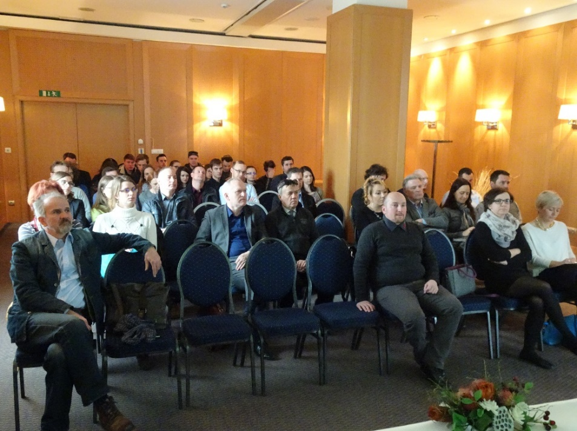

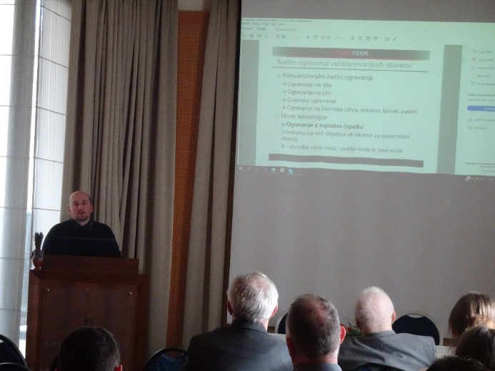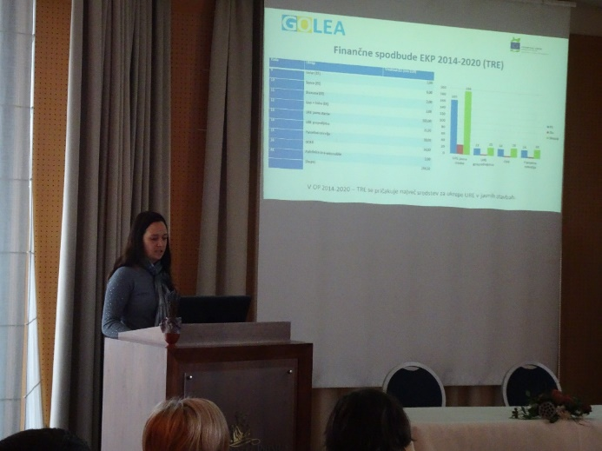

<event 2>

Title: STAKEHOLDER SEMINAR (Energy policies, founding possibilities)
Date: 20.9.2017
Place: Hotel Mitra, Ptuj

Participants: Energy company, energy agencies, research organization.

The aim of the seminar has been to provide participants with knowledge on:
- policy analysis – how to collect data, where to search for the data and how to include the data in concrete project ideas
- financial programs and
- funding opportunities for their project ideas.

The thematic of the seminar has led to an open discussion, where participants shared their knowledge and experiences about funding mechanisms and programmes. It was an excellent opportunity for the participants to get a better overview about different funding opportunities and to gain knowledge of national energy policies.

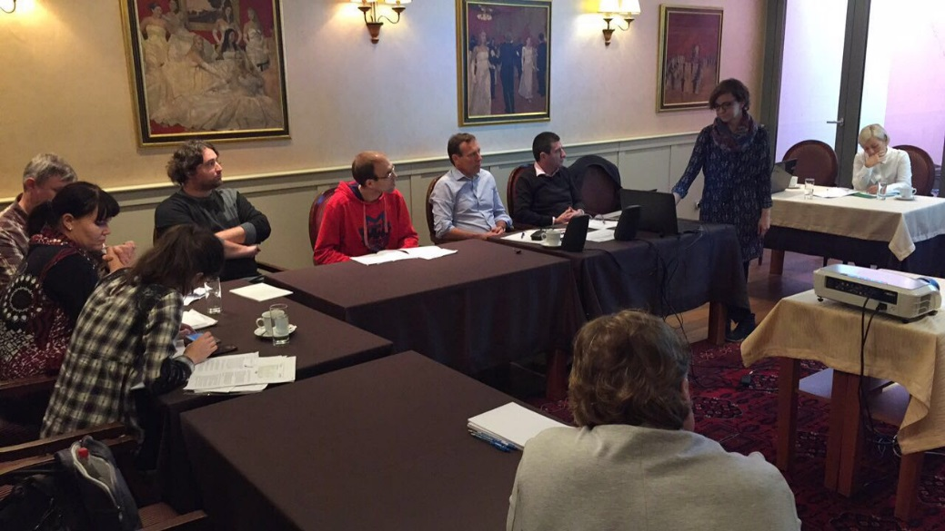

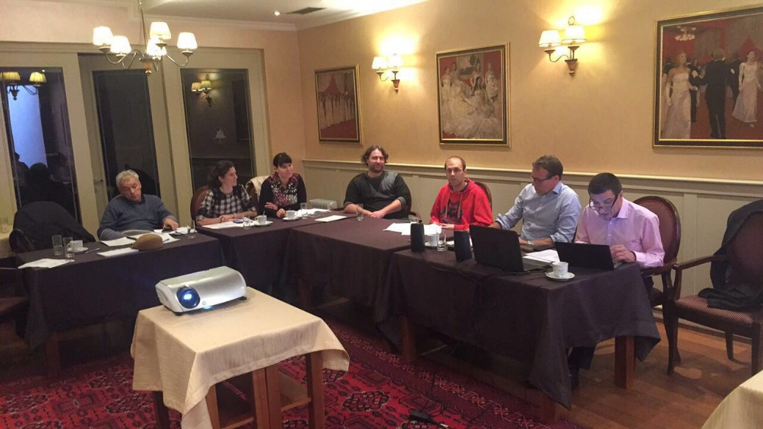
<event 3>

Title: Energy planning (Energetsko načrtovanje)
Date: 11.4.2018
Place: LEA Spodnje Podravje, Ptuj

Participants: The training was held in a smaller group prepared for forerunners, especially for those also participating in the Boot camp (Budapest)

The aim of the event has been to provide our most important stakeholders (forerunners) with knowledge on energy planning. At the training they became familiar with the Regional energy profile that was developed within WP3 and serves as a basis for Energy Visions. Through the training the participants also received basic knowledge on energy visioning and road mapping process and how to involve different stakeholders into that process. Through the regional training the participants received the information’s and gained knowledge needed for the more intensive training in Budapest (Boot camp). The regional training has been mainly linked to the outputs of WP3 and the training topic has led to a discussion where the main challenges for Podravje until 2050 have been discussed.

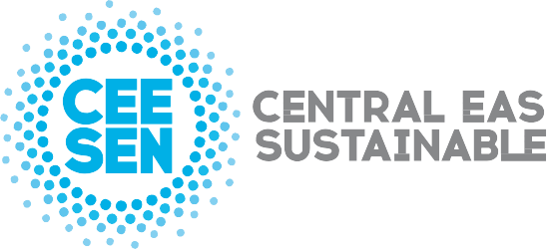

Publisher: CEESEN
All images © CEESEN 2018
All Rights Reserved
Reproduction is authorised, provided the source is acknowledged.

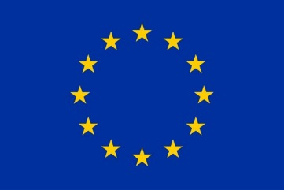
This publication is compiled within the PANEL2050 project “Partnership for New Energy Leadership”. This project has received funding from the European Union’s Horizon 2020 research and innovation programme under the grant agreement No 696173. Disclaimer: The sole responsibility for the content of this material lies with the authors. It does not necessarily represent the views of the European Union and neither EASME nor the European Commission are responsible for any use of this material.

