CEESEN
Trainings report
per country – Poland

- Stakeholder and forerunner trainings / events overview

Title of the event | Date, place | Focus
Possibilities of financing activities related to improving air quality in Mazovia. Project preparation and project management - Transition to low-carbon energy? Together it is possible. | 15.09.2017, Skórzec | Training for stakeholders on transition to low-carbon community
Possibilities of financing activities related to improving air quality in Mazovia. Project preparation and project management - Transition to low-carbon energy? Together it is possible. | 15.09.2017, Wodynie | Training for stakeholders on transition to low-carbon community
Possibilities of financing activities related to improving air quality in Mazovia. Project preparation and project management - Transition to low-carbon energy? Together it is possible. | 22.09.2017, Kotuń | Training for stakeholders on transition to low-carbon community
Possibilities of financing activities related to improving air quality in Mazovia. Project preparation and project management - Transition to low-carbon energy? Together it is possible. | 22.09.2017, Siedlce | Training for stakeholders on transition to low-carbon community
Possibilities of financing activities related to improving air quality in Mazovia. Project preparation and project management - Transition to low-carbon energy? Together it is possible. | 29.09.2017, Korczew | Training for stakeholders on transition to low-carbon community

- Detailed description of particular events

Training 1

Title: Possibilities of financing activities related to improving air quality in Mazovia. Project preparation and project management - Transition to low-carbon energy? Together it is possible.
Date: 15.09.2017
Place: Wodynie
Participants: 24
Brief description:
During the training there were session on topics related to low-emissivity. The training program contained lectures:
- Save energy - protect the climate
- Possibilities of financing activities related to improving air quality in Mazovia
- Energy planning in the commune including dispersed energy sources
- Energy management in the commune – a way to a low-emission economy
- Strategic energy partnerships PPP and energy cooperatives

Photos:

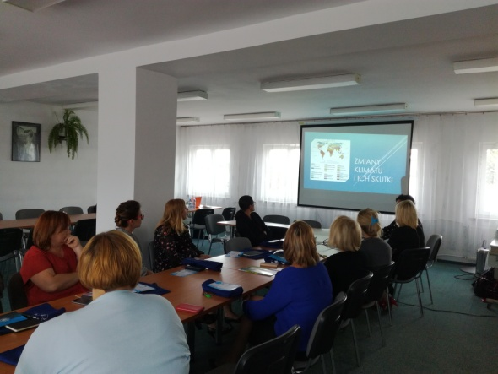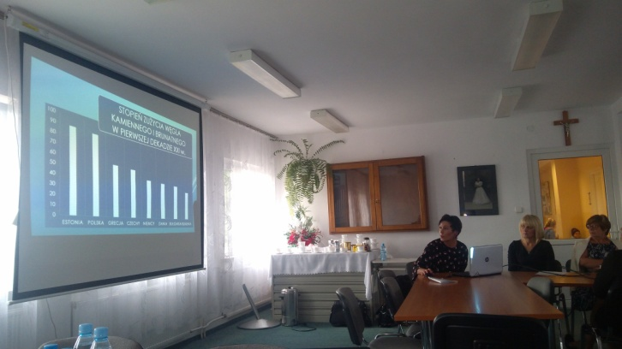

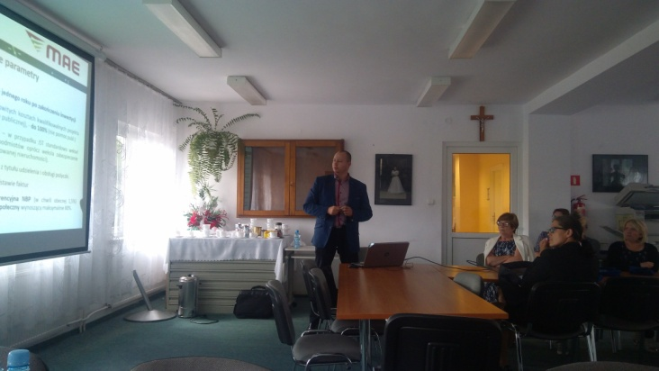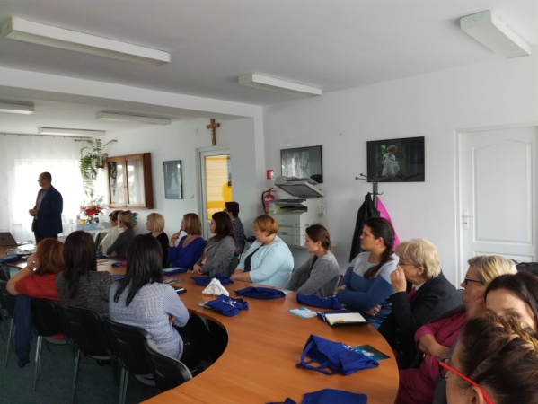

Training 2

Title: Possibilities of financing activities related to improving air quality in Mazovia. Project preparation and project management - Transition to low-carbon energy? Together it is possible.
Date: 15.09.2017,
Place: Skórzec
Participants: 19
Brief description :
During the training there were session on topics related to low-emissivity. The training program contained lectures:
- Save energy - protect the climate
- Possibilities of financing activities related to improving air quality in Mazovia
- Municipal energy strategy and hierarchical planning in the commune
- Energy management in the commune – a way to a low-emission economy
- Replacement of heat sources in residential buildings - project preparation and project management
- Strategic energy partnerships PPP and energy cooperatives

Photos:

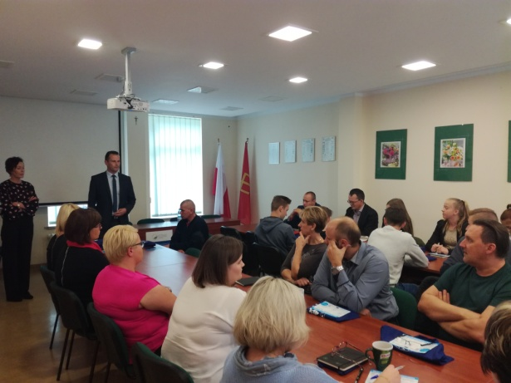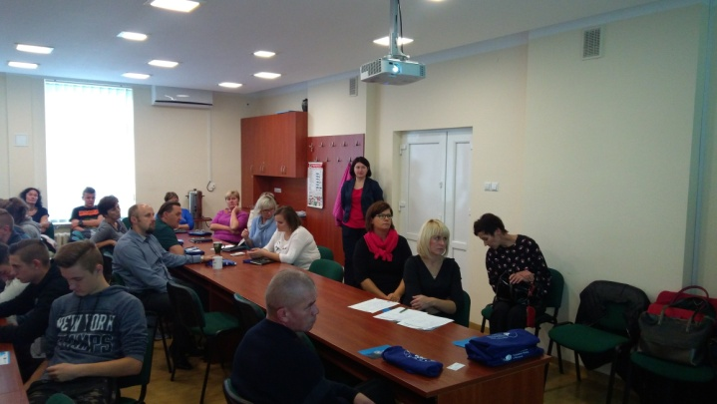

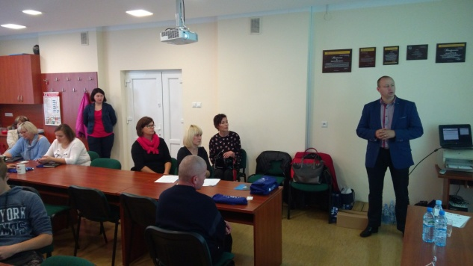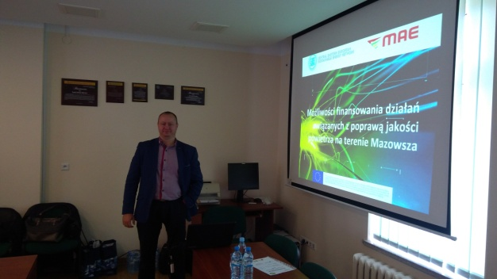

Training 3:

Title: Possibilities of financing activities related to improving air quality in Mazovia. Project preparation and project management - Transition to low-carbon energy? Together it is possible.
Date: 22.09.2017
Place: Kotuń
Participants: 38
Brief description:
During the training there were session on topics related to low-emissivity. The training program contained lectures:
- Save energy - protect the climate
- Possibilities of financing activities related to improving air quality in Mazovia
- Energy planning in the commune including dispersed energy sources
- Energy management in the commune – a way to a low-emission economy
- Replacement of heat sources in residential buildings - project preparation and project management

Photos:

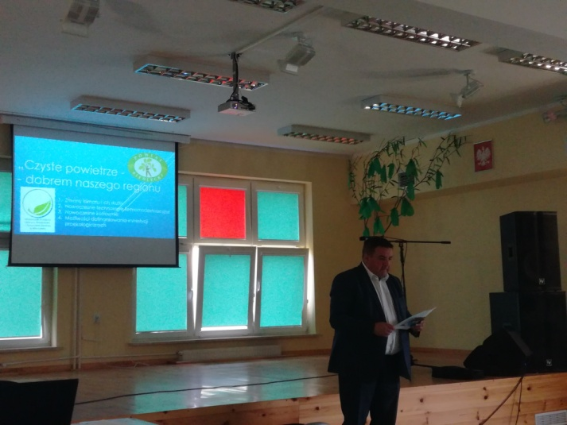

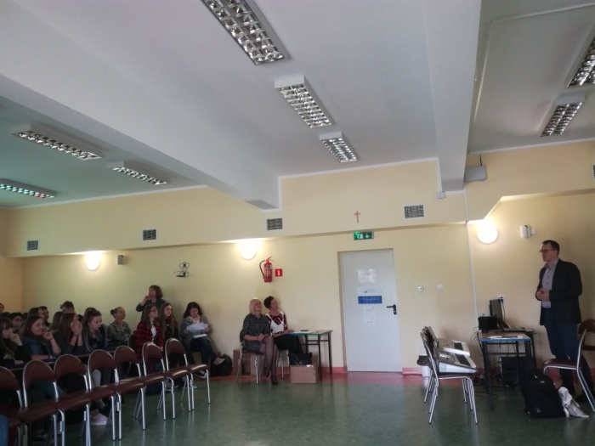

Training 4:

Title: Possibilities of financing activities related to improving air quality in Mazovia. Project preparation and project management - Transition to low-carbon energy? Together it is possible.
Date: 22.09.2017
Place: Siedlce
Participants: 28
Brief description
During the training there were session on topics related to low-emissivity. The training program contained lectures:
- Save energy - protect the climate
- Possibilities of financing activities related to improving air quality in Mazovia
- Energy planning in the commune including dispersed energy sources
- Energy management in the commune – a way to a low-emission economy
- Replacement of heat sources in residential buildings - project preparation and project management

Photos

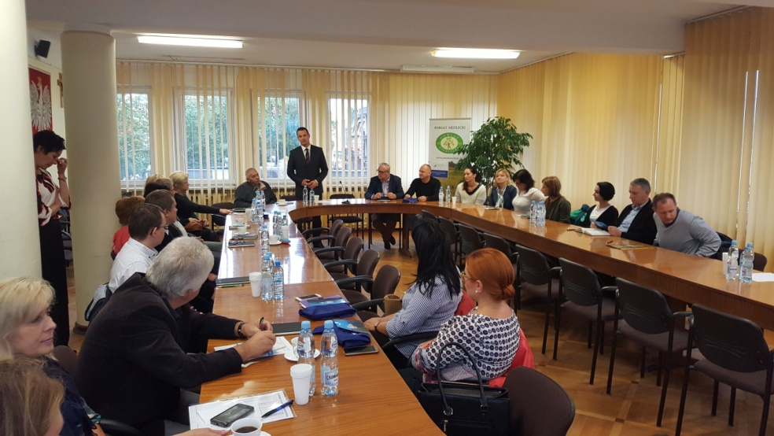

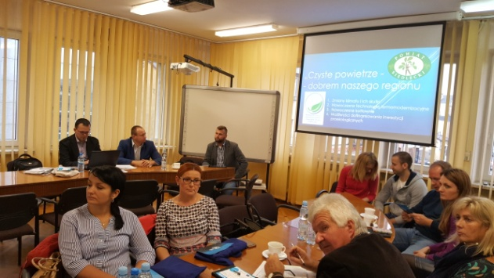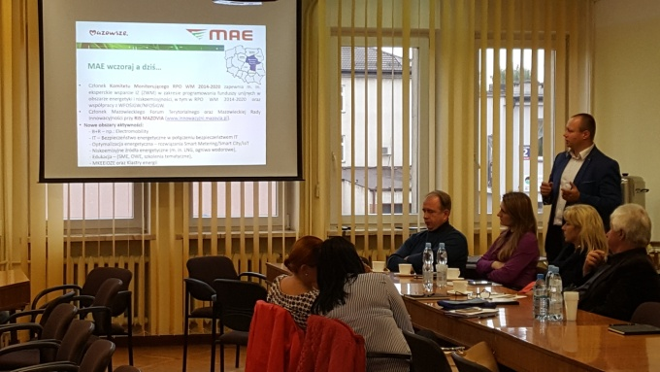

Training 5:

Title: Possibilities of financing activities related to improving air quality in Mazovia. Project preparation and project management - Transition to low-carbon energy? Together it is possible.
Date: 29.09.2017
Place: Korczew
Participants: 38
Brief description
During the training there were session on topics related to low-emissivity. The training program contained lectures:
- Save energy - protect the climate
- Possibilities of financing activities related to improving air quality in Mazovia
- Municipal energy strategy and hierarchical planning in the commune
- Energy management in the commune – a way to a low-emission economy
- Replacement of heat sources in residential buildings - project preparation and project management
- Strategic energy partnerships PPP and energy cooperatives

Photos:

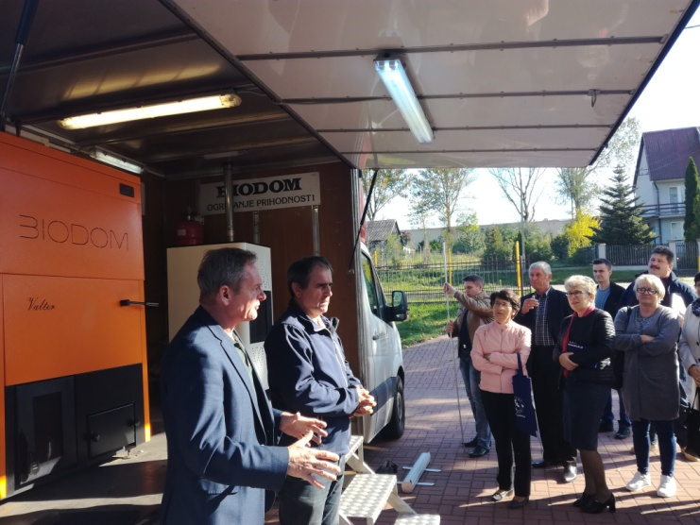

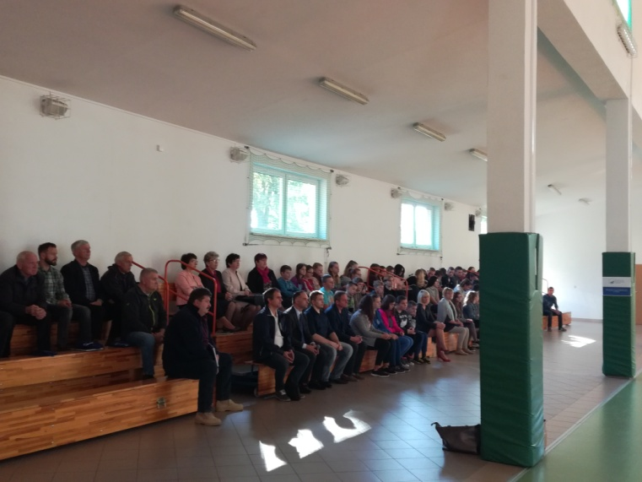

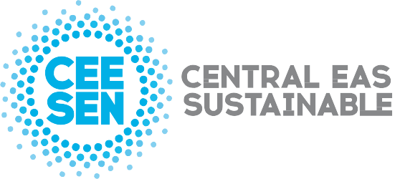

Publisher: CEESEN
All images © CEESEN 2018
All Rights Reserved
Reproduction is authorised, provided the source is acknowledged.

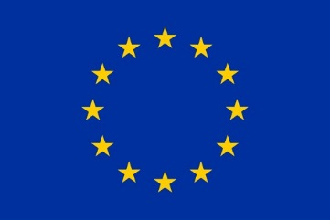
This publication is compiled within the PANEL2050 project “Partnership for New Energy Leadership”. This project has received funding from the European Union’s Horizon 2020 research and innovation programme under the grant agreement No 696173. Disclaimer: The sole responsibility for the content of this material lies with the authors. It does not necessarily represent the views of the European Union and neither EASME nor the European Commission are responsible for any use of this material.

