CEESEN
Trainings report
MACEDONIA

- Stakeholder and forerunner trainings / events overview

Event | Title of the event | Date, place | Focus
1. | Stakeholder engagement and motivation | 06.10.2017  Kumanovo | - Introduction  - Mapping stakeholders  - Stakeholder analysis  - Forerunners; Identification  - Creating strategies for securing and maintaining the interest and motivation of stakeholders in a sustainable manner  - The process of mapping of the directions of the energy transition  - Methods for engaging stakeholders at different stages of the mapping process  - CESEEN-Central and Eastern Europe Sustainable Energy Network  - Exercises and discussions
2. | Energy Roadmapping | 20.12.2017  Kumanovo | - Introduction  - Roadmaps for the Energy Transition Strategy  - Energy Roadmapping Model  - Development of the Energy Profile of the NEPR  - Collection of baseline assessment data  - Model of the Energy Profile of the region  - Development of the Energy Vision of the region  - Exercises and discussions
3. | Speaking in public and communicating with the media and politicians | 07.03.2018  Kumanovo | - Introduction  - Speaking in public  - Communication with the media  - Communicating with politicians  - Exercises and discussions
4. | EU Fundraising and Project Writing | 12.06.2018  Kumanovo | - Introduction  - Project writing and EU Fundraising – “Narrative” and Logical frames  - Identifying the funding opportunities / HORIZON 2020 projects  - Proposals for writing EU projects / Projects for EU  - Defining the problem  - What do financiers require? Their impact  - Project Results (Output Results, Overtime Results, Results Delivered)  - Project implementation  - Structuring the tasks  - Timeframe of the project and division of work  - Budgeting the projects  - Risk assessment  - Exercises and discussions
5. | Process of development of Regional Energy Map 2050 and Policy Analysis | 13.06.2018  Kumanovo | - Development of Regional Energy Map 2050 (ЕУ Energy Roadmapping 2050)  - Energy vision 2050 of the NorthEast Planning Region - Review of the Proposal  - Policy Analysis
6. | Development of Regional Energy Map 2050 for NEPR and Action Plan | 14.06.2018  Kumanovo | - Introduction  - Development of Regional Energy Roadmapping  - Development of Regional Energy Roadmapping for NEPR  - Development of the Action plans  - Exercises and discussions

Detailed description of particular events
Event 1
Title: Stakeholder engagement and motivation
Date: 06.10.2017
Place: Kumanovo, The City Council Meeting Room
Participants: 20
The first of the planned trainings and panel discussions in the NorthEast Planning Region was held in Kumanovo, on which the stakeholders in the region were identified –the municipalities, the Council of the Region, the Center for Regional Development, the business sector, non-governmental organizations and the media. The potential forerunners were identified, analyzed and discussed. They are also important segment in the establishment of the energy efficiency network of Central and Eastern Europe-CESEEN.
The process of mapping of the direction of the energy transition, as well as the creating strategies and methods for engaging stakeholders and sustaining their interest and motivation were introduced through the exercises and discussions.
The workshop shows the interest of the stakeholders for the need of development of Regional energy transition strategy. Until now, no such analyses, discussions and strategies are developed in the region.

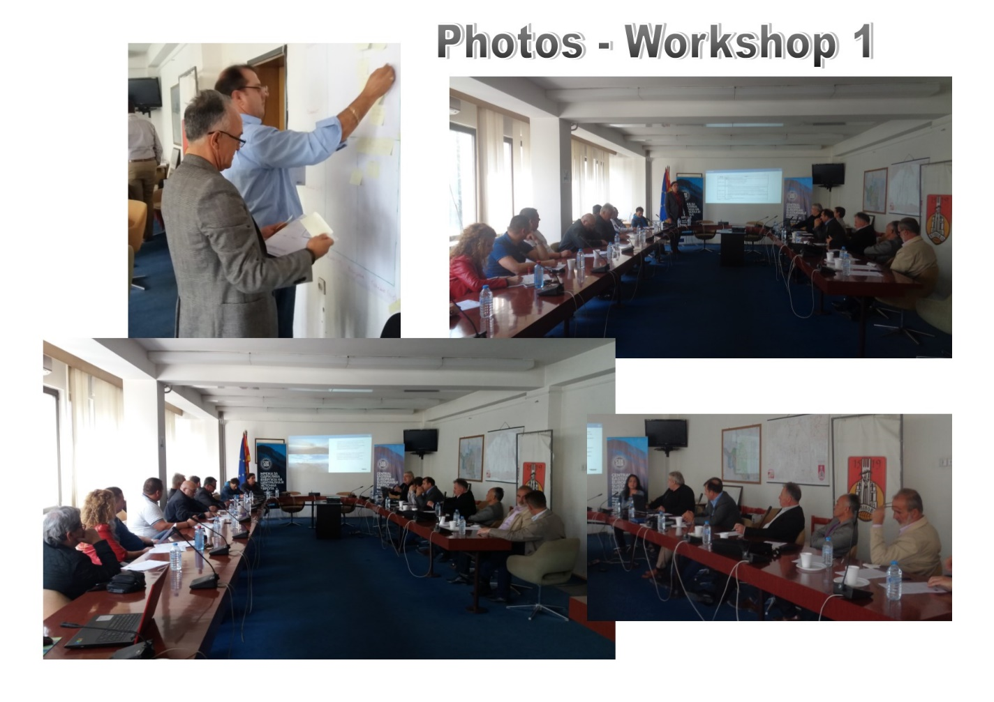

Event 2
Title: Energy Roadmapping
Date: 20.12.2017
Place: Restaurant “Gracija”, Kumanovo
Participants: 24
The purpose of the training was to give an introduction to the process of developing the Energy Profile of the region and the energy transition map for the public and the business sector in the region, as well as for the citizens in: reducing energy consumption and greenhouse gas emissions; the use of local renewable resources for energy production; creating local jobs and reducing energy costs.
The model of the Energy Profile of the region and the methods for collection of baseline asessment data for the Energy Profile were introduced. The participants were introduced with the inportance of the Energy Vision of the region and through exercises work on the development of the first draft Energy Vision of the Region.
The tasks for data collection were assigned to each of the identified forerunner.

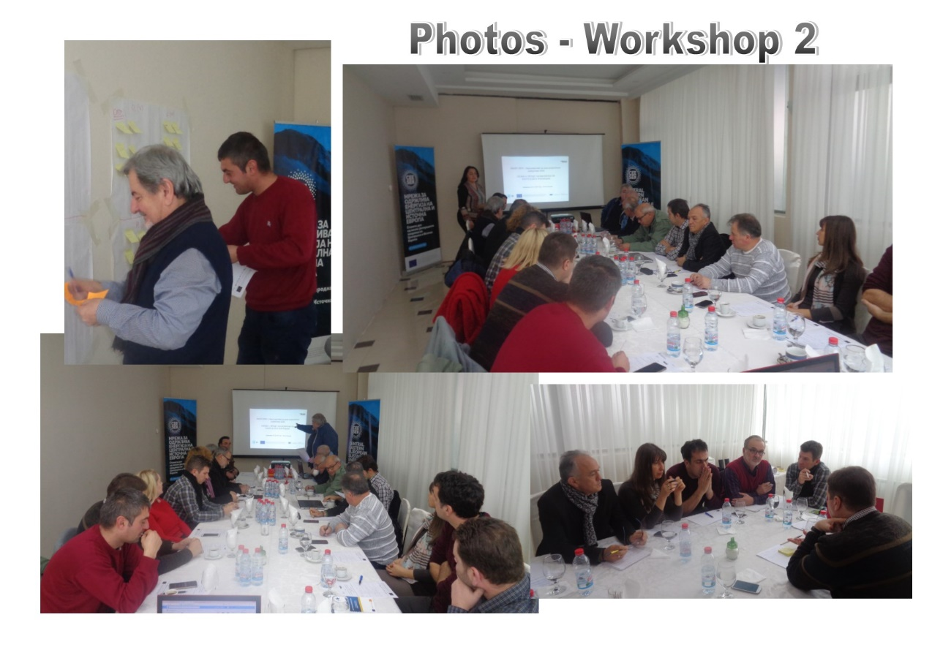

Event 3
Title: Speaking in public and communicating with the media and politicians
Date: 07.03.2018
Place: Restaurant “Gracija”, Kumanovo
Participants: 36
BDS organized the third training with the stakeholders on the “Public speaking and Communication with media and politicians”, which was attended by the mayors, employees in the Center of NorthEast Planning region and the municipalities; members of the NGOs and Business sector.
The main purpose of the training was to introduce to the participants the importance of the Public Speaking and Communication with Media and Politicians in modern information and media world and in the same time to provide tools for identifying, planning and establishing communication in the process of energy transition.
During the workshop many exercises and discussions were used to involve the participants in the learning process.

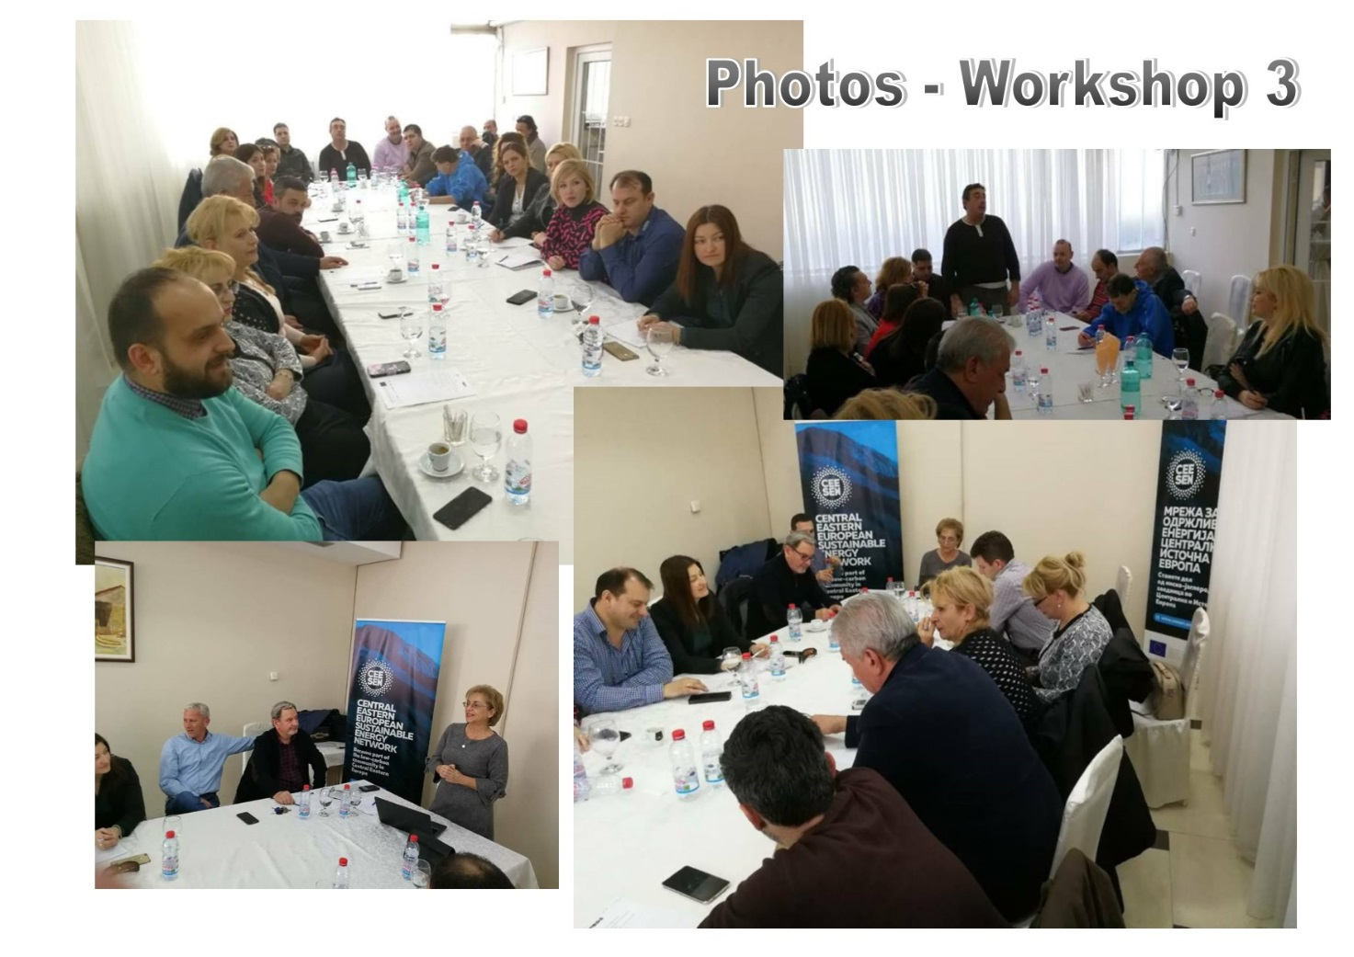

Event 4
Title: EU Fundraising and Project Writing
Date: 12.06.2018
Place: Restaurant “Gracija”, Kumanovo
Participants: 33
BDS organized the fourth training on the topic “EU Fundraising and Project Writing” in cooperation with the University of Tartu, Estonia. Experts for the University of Tartu held the training. In the first half of the workshop, the participants had an opportunity to get familiar with approaches used for Project Writing and EU Fundraising; identifying the funding opportunities (particularly HORIZON 2020 projects).
In the second half of the workshop, the participants were introduced with the writing of Proposals for EU projects. The main steps of the process of the proposal preparation and implementation: defining the problem; financiers requirement; Project Results; Structuring the Tasks; Timeframe and division of work; Budgeting and Risk Assessment were introduced.
During the workshop, the practical examples were shared and the participants were involved through the exercises and discussions.
The workshop was held in English and Macedonian languages.
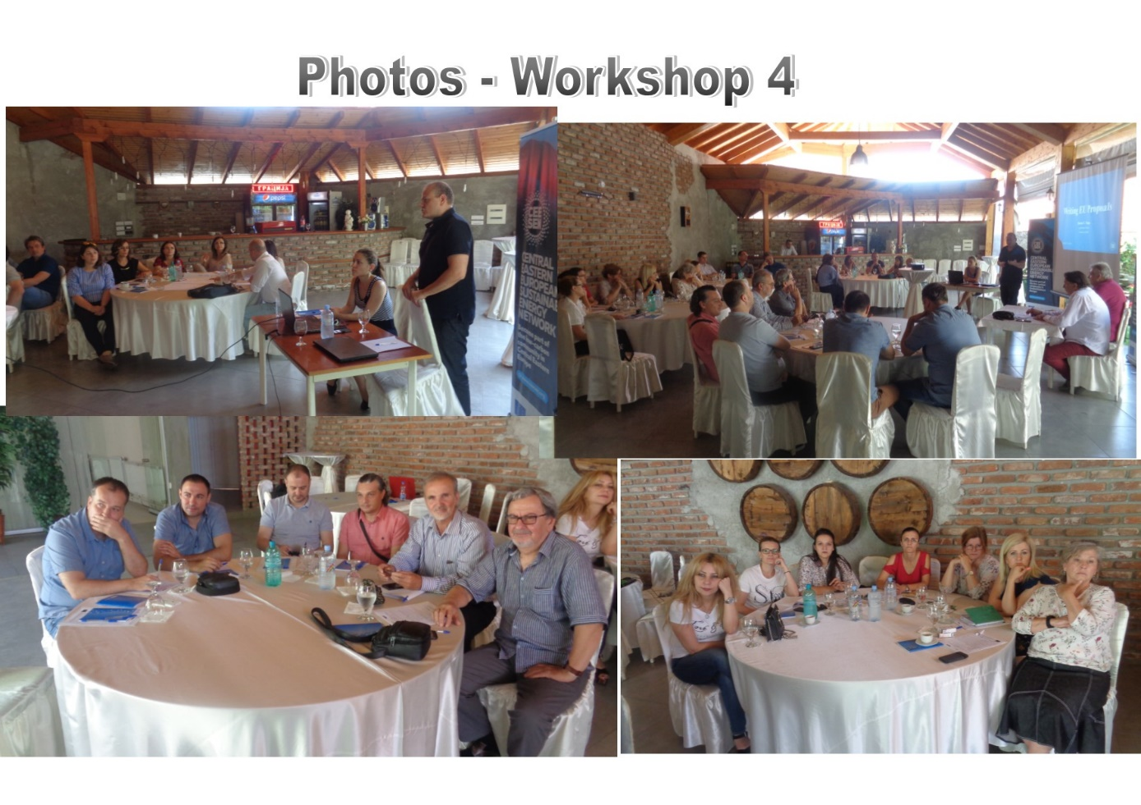

Event 5
Title: Process of development of Regional Energy Map 2050 and Policy Analysis
Date: 13.06.2018
Place: Kumanovo, The City Council Meeting Room
Participants: 31
The fifth training on the topic “Process of development of Regional Energy Map 2050 and Policy Analysis” was organized with support of the Consortia members CONPLUSULTRA, Austria and the University of Tartu, Estonia. The participants from the Ministry of Local Self-Government, Mayors and members of municipal councils from 6 municipalities in the NEPR, Representatives of the municipalities from the NEPR responsible for issues related to development and energy efficiency; Employees from the Center for development of the NEPR; Representatives of the business sector and NGO were introduced with the process of the development of Regional Energy Map 2050 (EU Energy Roadmapping 2050).
During the workshop the draft Energy Vision 2050 of the NorthEast Planning Region was discussed and reviewed. The Panel discussion gave an opportunity to the policy makers to share the views for the energy transition of the region on short and long term period.
Deputy Minister of Local Self-Government, Dejan Pavleski, stressed that activities and results of the PANEL 2050 project realized in NEPR in the Republic of Macedonia, will serve as pilot approach and method for policy development and action planning for other regions in the country, as well as for increasing the awareness for the importance of identification and development of energy transition strategies in the process of developing the new national strategy for balanced regional development.
The session of policy analyses followed and the participants were introduced with the methods of analyses and actively participated in the exercises and discussion.
Simultaneous translation was provided in English and Macedonian languages.
The media took several interviews from the Deputy Minister, Mayors and the Trainers.

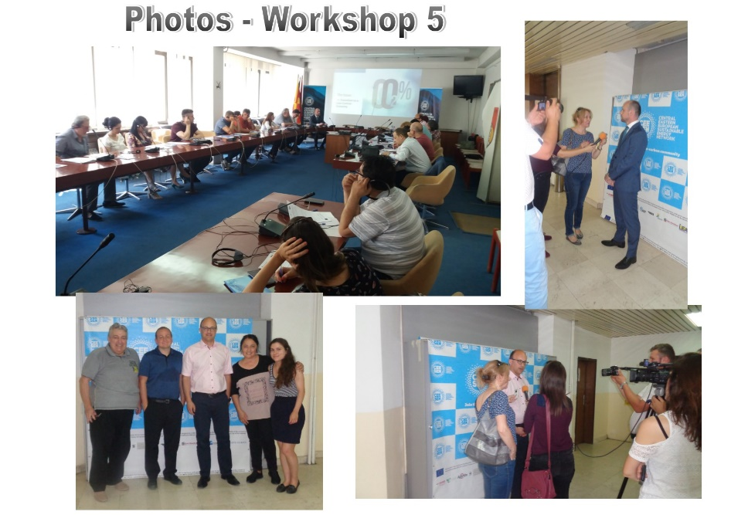

Event 6
Title: Development of Regional Energy Map 2050 for NEPR and Action Plan
Date: 14.06.2018
Place: Restaurant “Gracija”, Kumanovo
Participants: 33
BDS organized the sixth training on the topic “Development of Regional Energy Map 2050 for NEPR and Action Plan” supported by Consortia members CONPLUSULTRA, Austria and the University of Tartu, Estonia.
The representatives of the NEPR municipalities responsible for issues related to development and energy efficiency; Employees from the Center for development of the NEPR; Representatives of the business sector and NGO took an active participation during the workshop.
The first half of the workshop focused on the introduction on Theory Development of Regional Energy Roadmapping, followed by exercises on introducing the Development of Regional Energy Roadmapping for NEPR (NorthEast Planning Region).
The second half of the workshop focused on development of Action Plan for energy transition and a preliminary identification of the areas of the energy roadmap which will be a subject of the action planning.
During the workshop, the practical examples were shared and the participants were involved through the exercises and discussions.
The workshop was held in English and Macedonian languages.

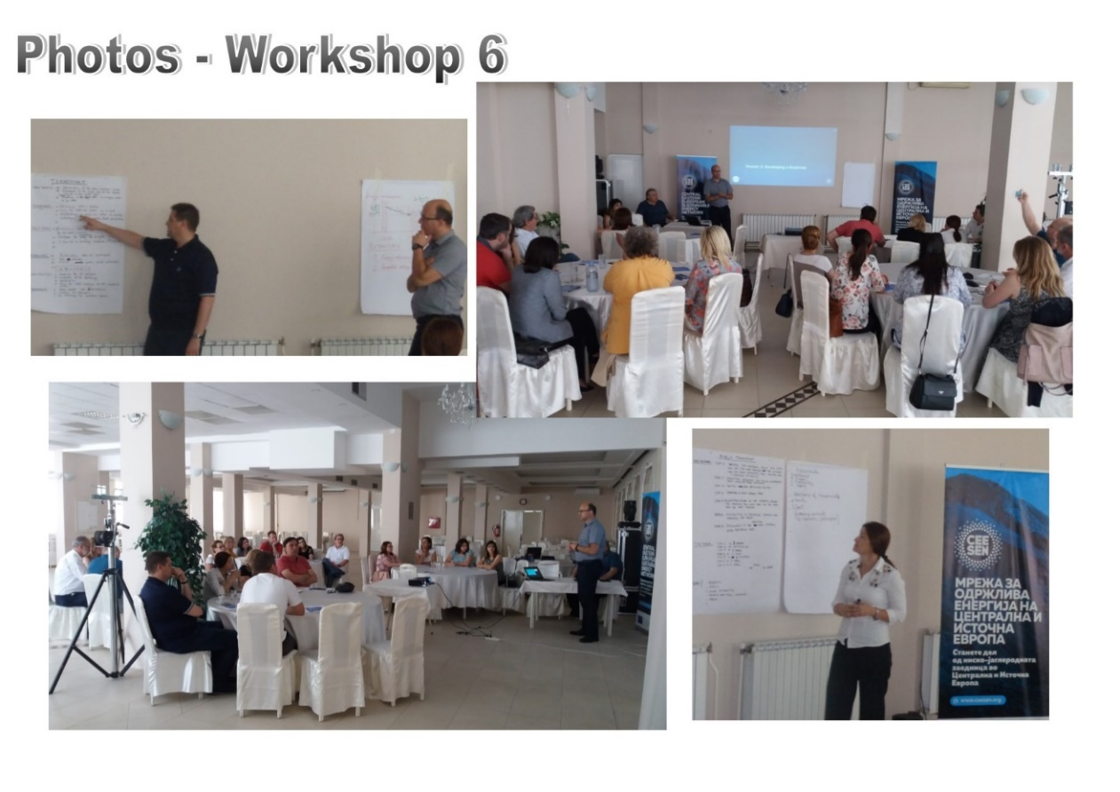

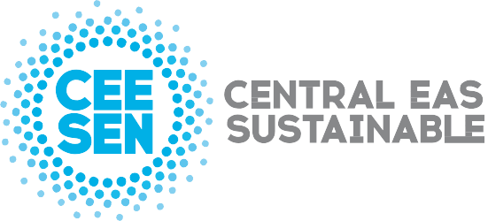

Publisher: CEESEN
All images © CEESEN 2018
All Rights Reserved
Reproduction is authorised, provided the source is acknowledged.

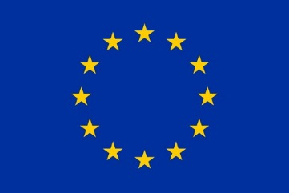
This publication is compiled within the PANEL2050 project “Partnership for New Energy Leadership”. This project has received funding from the European Union’s Horizon 2020 research and innovation programme under the grant agreement No 696173. Disclaimer: The sole responsibility for the content of this material lies with the authors. It does not necessarily represent the views of the European Union and neither EASME nor the European Commission are responsible for any use of this material.

