CEESEN
Trainings report
per country – Lithuania

- Stakeholder and forerunner trainings / events overview

Title of the event | Date, place | Focus
Project preparation - how to write project proposal | 12.01. 2018, Ignalina | High-level training for public authorities about preparation of projects
Stakeholder engagement – how to interact and work with | 12.01. 2018, Ignalina | Practical training for regional public authorities
Fundraising – from idea to realisation | 12.02. 2018, Ignalina | Practical training for regional authorities, NGOs and municipalities
Marketing – how to promote your organization | 12.02. 2018, Ignalina | Practical training for regional authorities, NGOs and municipalities
.
- Detailed description of particular events

Training 1

Title: Project preparation - how to write project proposal
Date: 12 th of January, 2018
Place: Ignalina, Lithuania

Participants: Forerunners and stakeholder of the project, regional authorities, other regional organizations

Brief description: the main focus of the training was on how to prepare realistic, useful and high quality proposal to get grants for implementation of energy related project. The requirements of different Lithuanian and European funds were presented and discussed with participants. The usefulness of grants for implementation of regional Energy strategies was discussed with forerunners and regional authorities.

Photos

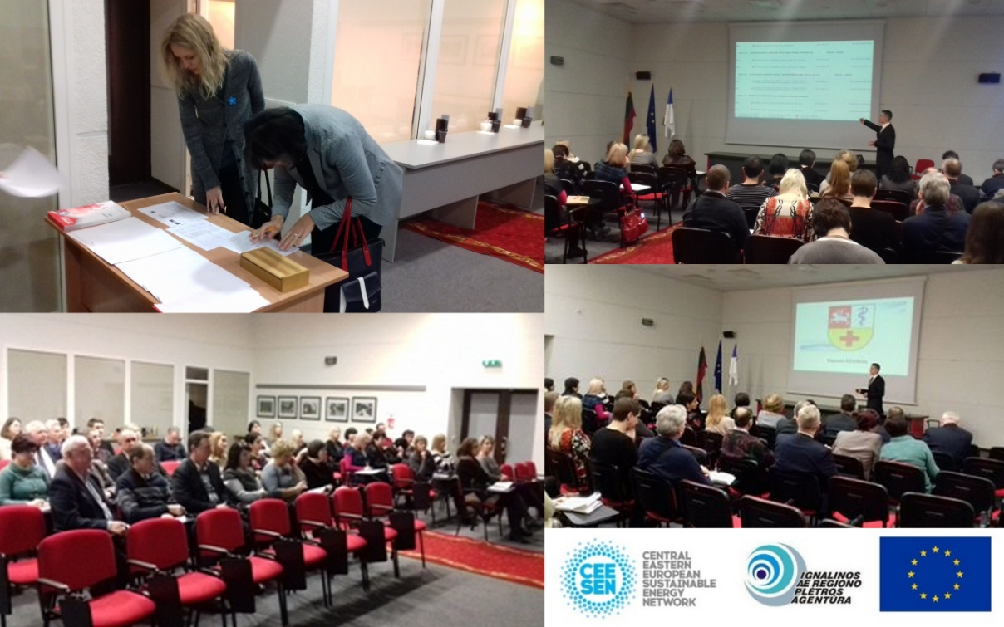

Training 2

Title: Stakeholder engagement – how to interact and work with
Date: 12th of January, 2018
Place: Ignalina, Lithuania

Participants: Forerunners and stakeholder of the project, regional authorities, other regional organizations

Brief description: The training was focused of stakeholders engagement subtleties – how to interact with them, how to present the idea, how to involve in project implementation and how to influence decision making process. The training was especially useful for forerunners as a help with involvement of regional and national authorities in implementation of action plans.

Training 3

Title: Fundraising – from idea to realisation
Date: 12th of Fabuary, 2018
Place: Ignalina, Lithuania

Participants: Participants: Forerunners of the project together with local regional authorities, NGO’s and other organization, 13 participants

Brief description: The purpose of the training was to introduce the participants of the seminar to different methods of attracting funds, such as events organization for fundraising purposes, grants, usage of mass financing (kick starters as example) and other methods. The fundraising as an instrument for implementation of regional Energy strategies was discussed with forerunners and regional authorities.

Training 4

Title: Marketing – how to promote your organization
Date: 12th of Fabuary, 2018
Place: Ignalina, Lithuania

Participants: Forerunners of the project together with local regional authorities, NGO’s and other organization, 13 participants

Brief description: The purpose of the training was to familiarize participants with the real meaning of marketing, pre-project work, the project's objectives and task forming process and the peculiarities of the work. The main focus was on creation of action plan and how to attract stakeholders with a help of marketing.

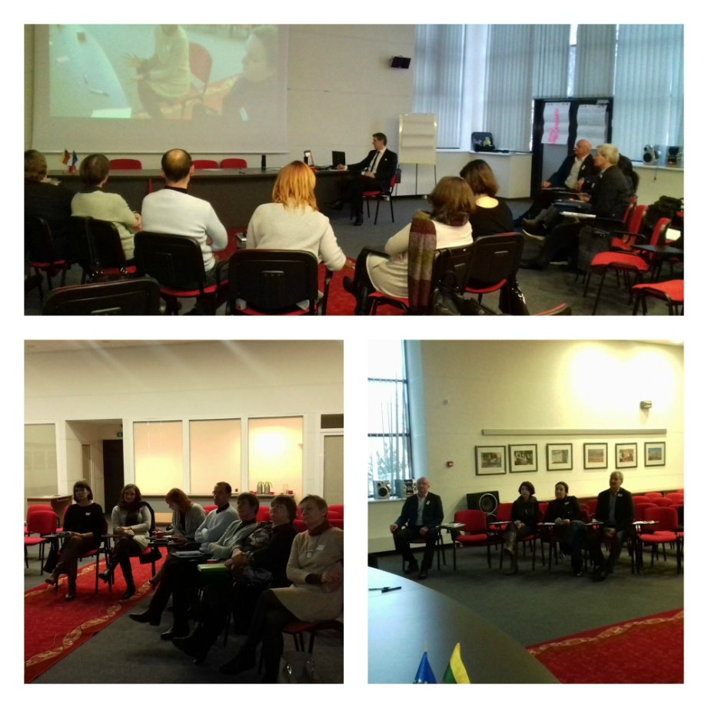

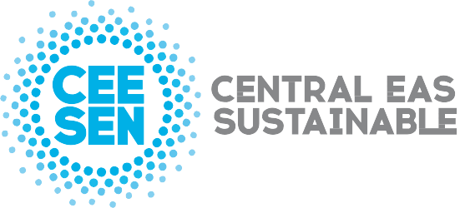

Publisher: CEESEN
All images © CEESEN 2018
All Rights Reserved
Reproduction is authorised, provided the source is acknowledged.

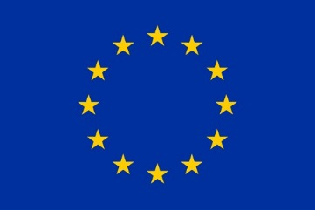
This publication is compiled within the PANEL2050 project “Partnership for New Energy Leadership”. This project has received funding from the European Union’s Horizon 2020 research and innovation programme under the grant agreement No 696173. Disclaimer: The sole responsibility for the content of this material lies with the authors. It does not necessarily represent the views of the European Union and neither EASME nor the European Commission are responsible for any use of this material.

