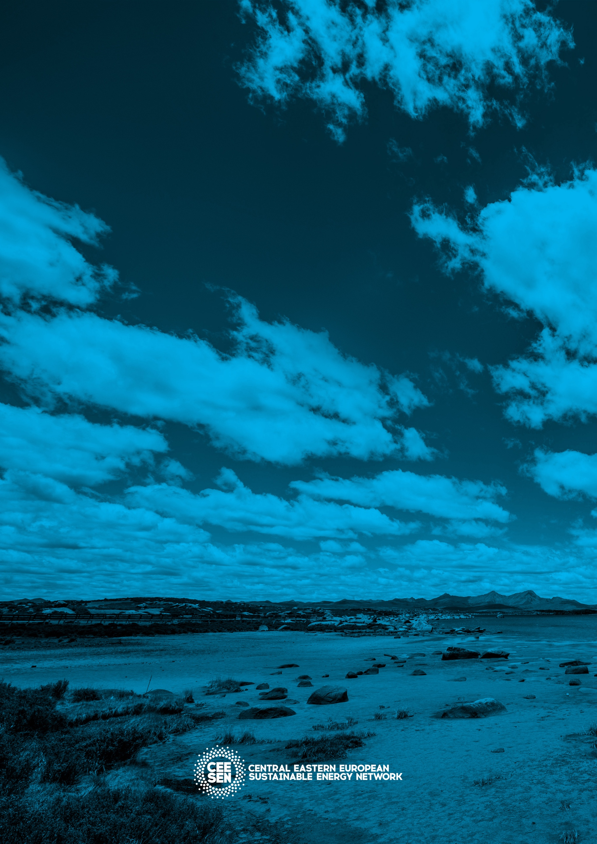

CEESEN
Trainings report
per country – Latvia

- Regional trainings / events overview

Title of the event | Date, place | Focus
Existing energy infrastructure -what is it and how to describe it? | 25.04.2017.,  Smiltene, Latvia | Energy management in the municipalities and municipalities’ involvement in the energy resources utilization planning: approaches and solutions
Data gathering and the development of a data basis | 31.05.2017.,  Cesvaine, Latvia | Data collection and analysis in a municipality
Experience exchange trip | 29.06.2017.,  Liepāja, Latvia | Leaders and forerunners in the energy sector. Importance of active engagement, Liepāja examples.
Energy planning | 29.09.2017.,  Rauna, Latvia | Stakeholder engagement and its role in the energy planning process and fundraising and project application writing for EU programs
Energy management system (EMS) development and implementation process in a municipality | 28.03.2018.,  Priekuļi, Latvia | Introduction about energy management system creation and introduction in a municipality and an organization: general requirements; energy overview; goals and action plans; implementation and actions + stakeholders’ presentations and workshop on the topic
EMS development key principles for a municipality building | 11.04.2018.,  Kocēni, Latvia | Step by step energy management development in a municipality building: energy overview, energy efficiency indicators, operative action and monitoring + stakeholders’ presentations and workshops on the topic
EMS development for all municipality buildings | 25.04.2018.,  Cēsis, Latvia | Energy mapping in the Vidzeme planning region, Step by step energy management development in several (all) municipality buildings: municipality energy policy, defining goals, action plans and defining priority actions, competency. Communication, documantation, procurement, and designing + stakeholders’ presentations and workshops on the topic
Energy management and municipalities’ energy plans | 9.05. 2018.,  Valmiera, Latvia | If and how to link energy management to the municipalities’ energy action plans? Why to do it? + concluding stakeholders’ presentations on the training cycle
Energy day in Valmiera and study trip to Estonia | 14-15 June 2018.,  Valmiera, Latvia  Valga and Tartu, Estonia | Presentations of municipalities’ Action plans, information about dissemination and an experience trip

Detailed description of particular events
<event 1>

Title: Existing energy infrastructure -what is it and how to describe it?
Date: 20.04.2017.
Place: Smiltene, Latvia

Participants: Municipalities’ representatives

Brief description (main outputs, conclusions, relation to other WPs): main outputs are stakeholder engagement and network strengthening, introduction to the energy management concept and PANEL 2050 and CEESEN network idea. We concluded that direct networking and meetings with the municipalities’ representatives of Vidzeme region is the best way to acquire fresh ideas and knowledge about cooperation and energy efficiency; we need to continue to strengthen the energy network and educate municipalities in energy targets. Relation to WP3 - regional energy strategies, data collection and WP 5 – sustainable CEESEN network.

Photos
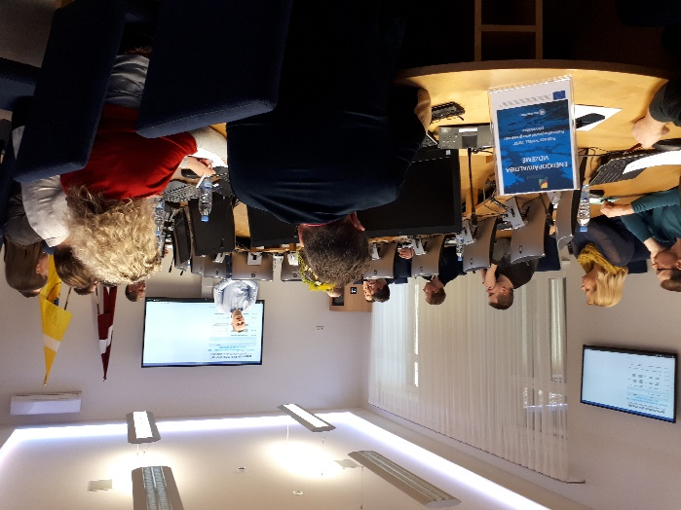 | 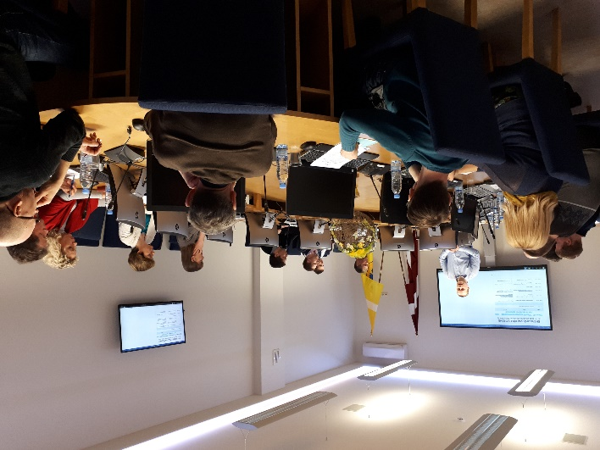
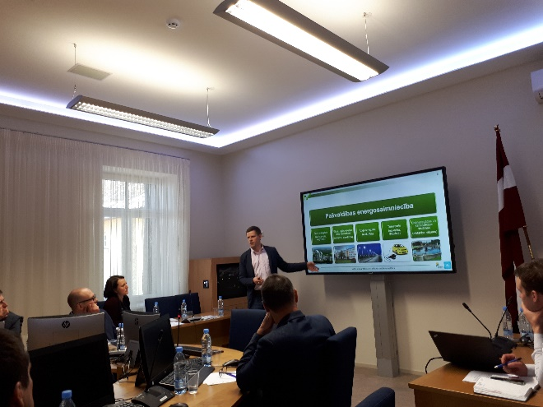 | 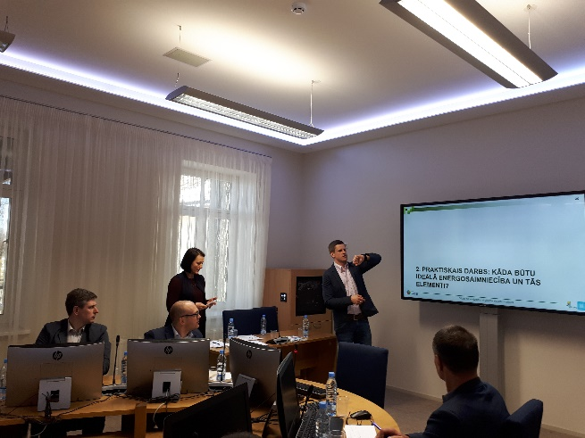

<event 2>

Title: Data gathering and the development of data basis
Date: 31.05.2017.
Place: Cesvaine, Latvia

Participants: Municipalities’ representatives

Brief description (main outputs, conclusions, relation to other WPs): Main outputs are straightening the link between municipalities and explanation about importance of regular energy data gathering and sharing of experience between stakeholders. We concluded that municipalities so far have had poor data gathering quality and experience and need information, tools and human resources to do so. Relation to WP3 - regional energy strategies, data collection.

Photos
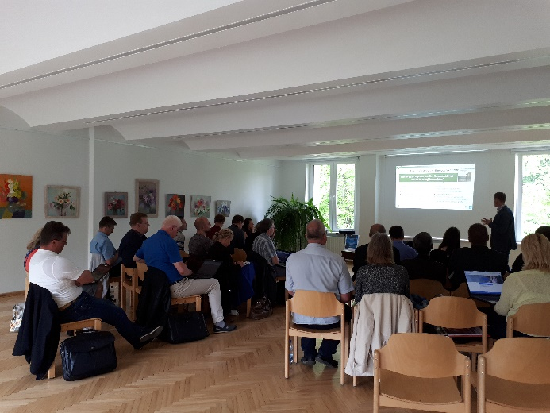 | 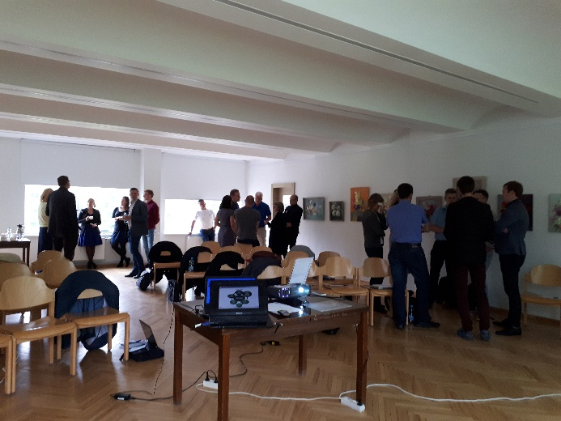
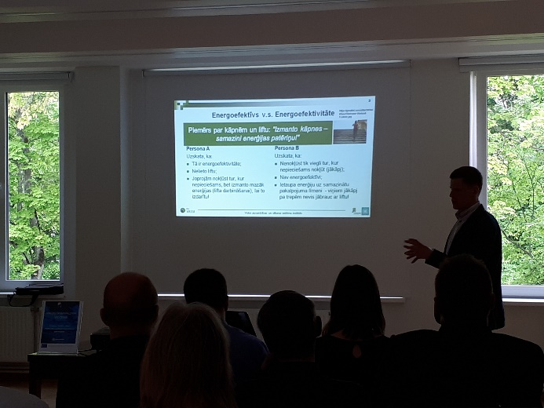 | 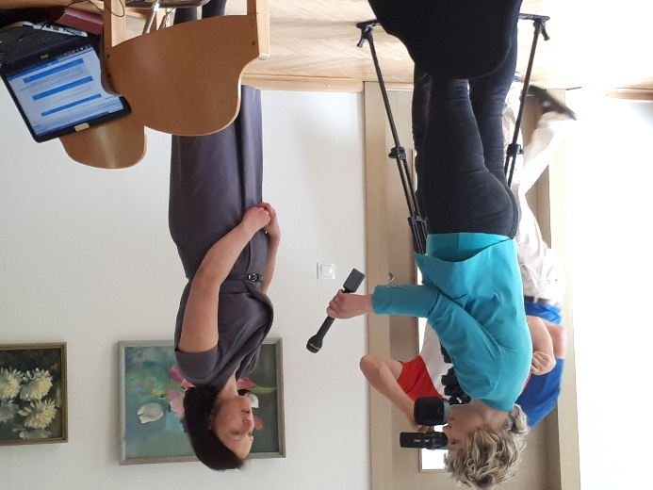

<event 3>

Title: Experience exchange trip
Date: 29.06.2017.
Place: Liepāja, Latvia

Participants: Municipalities’ representatives

Brief description (main outputs, conclusions, relation to other WPs): Main outputs are
Experience exchange about energy efficiency and similar topics among stakeholders in other regions as well as strengthening of network and networking skills. Our conclusion is that there are a lot of good examples and experience in Latvia, but people do not tell about it enough and do not know how to do it. Relation to WP4 dissemination of the project in other regions and WP5 – development of sustainable energy network.

Photos

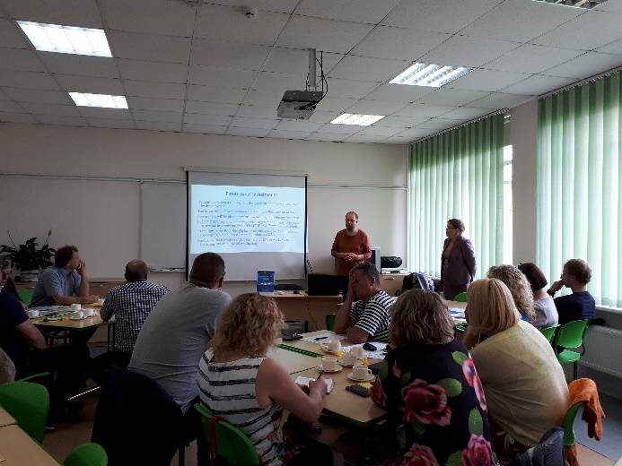 | 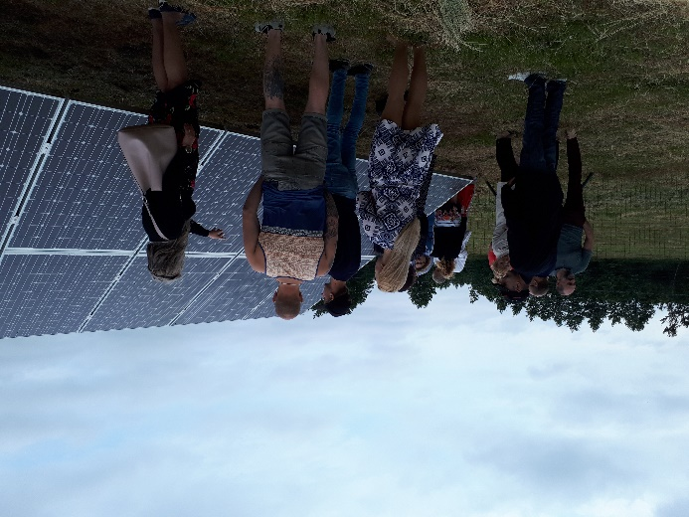
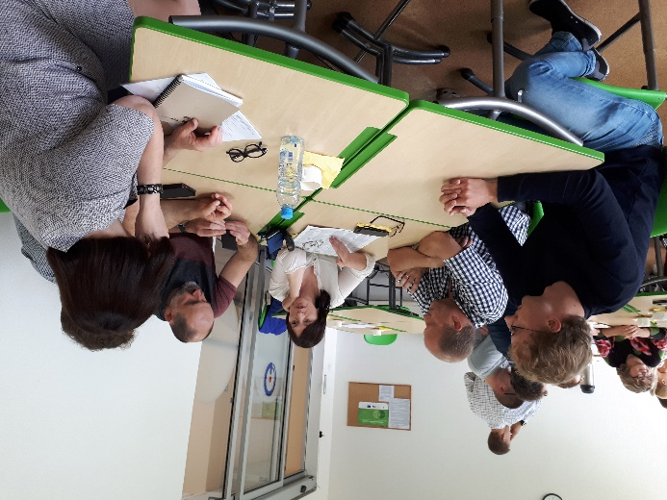 | 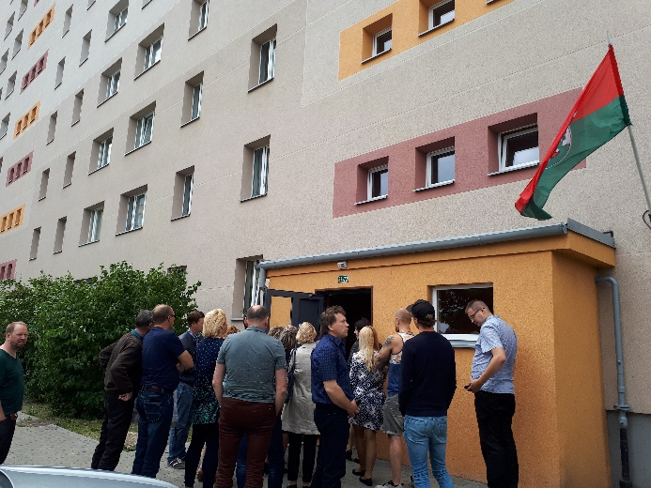

<event 4>

Title: Energy planning
Date: 29.09.2017.
Place: Rauna, Latvia

Participants: Municipalities’ representatives

Brief description (main outputs, conclusions, relation to other WPs): Main outputs are grounded idea of the necessity of the municipality engagement in energy planning process and collect knowledges and ideas of how to apply for energy efficiency funds. Main conclusions are that municipalities are active, but they tend to lack information about tools and approaches towards sustainable energy management. Relation to WP3 – data collection.

Photos

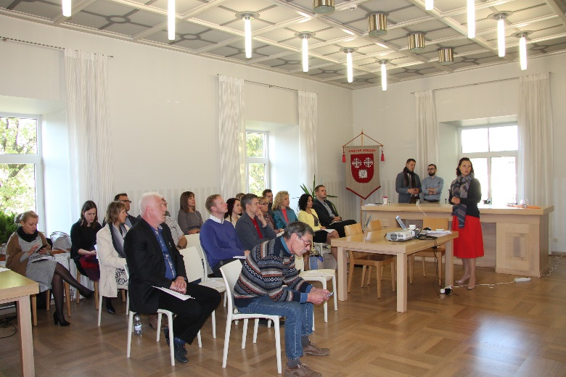 | 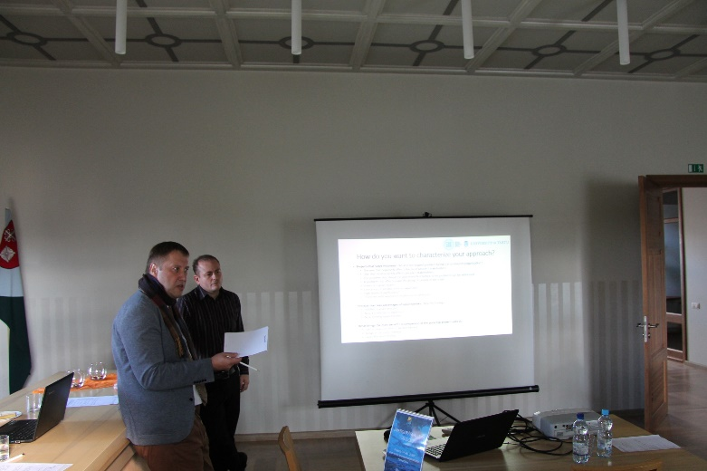
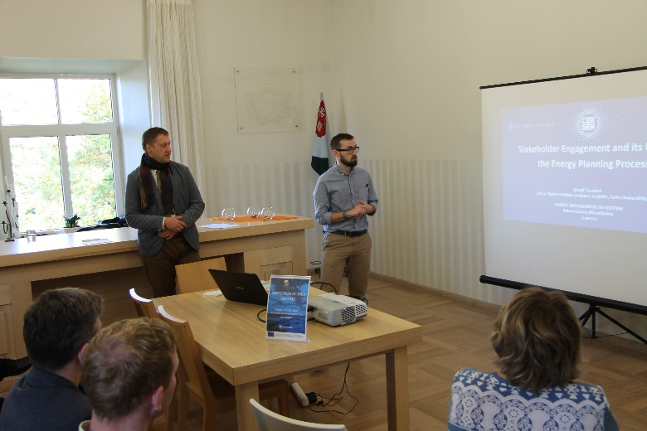 | 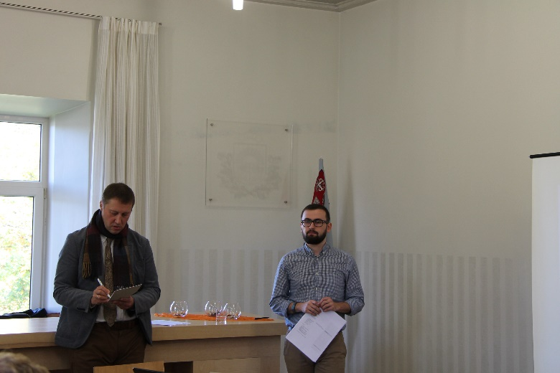

<event 5>

Title: Energy management system (EMS) development and implementation process in a municipality
Date: 28.03.2018.
Place: Priekuļi, Latvia

Participants: Municipalities’ representatives

Brief description (main outputs, conclusions, relation to other WPs): This event was first in a four trainings cycle dedicated to development of Action plans. Main outputs after the first training day are engaged municipalities towards writing their own energy action plan, gathered first actual data for the plan and sharing and presenting them with others. Main conclusions are that municipalities are doing a lot in the field of energy efficiency, but the actions lack systemic approach. The event is linked to the WP3 data gathering, development of Action plans and road-mapping process.

Photos

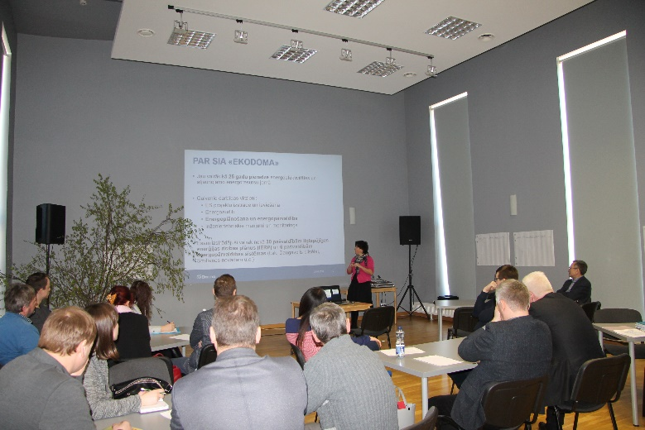 | 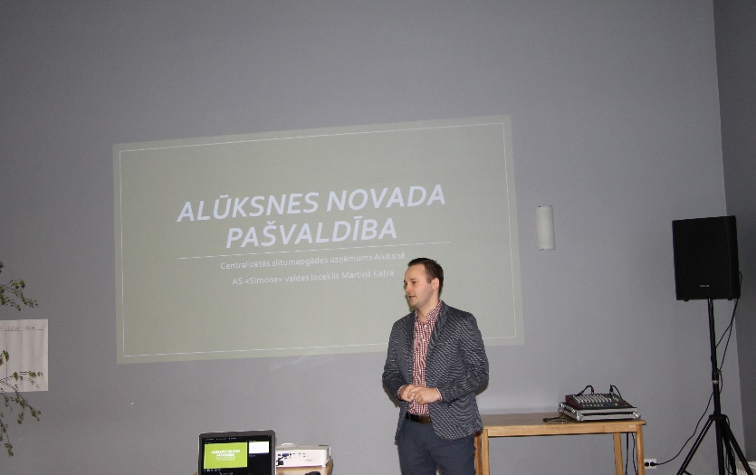
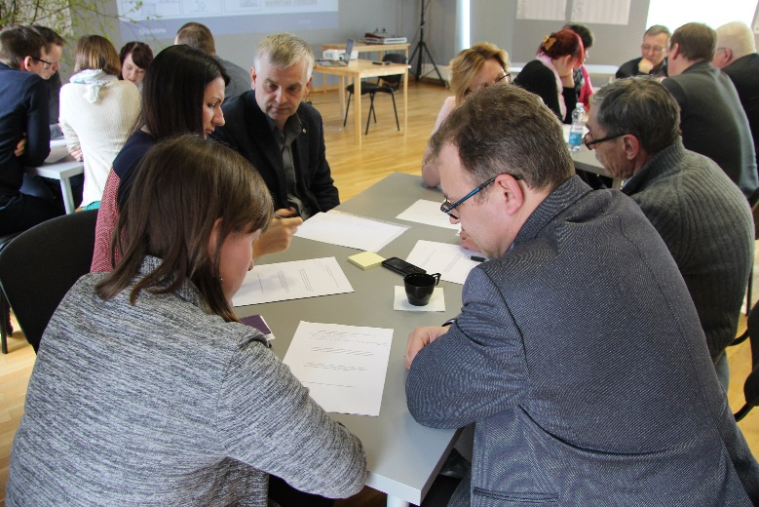 | 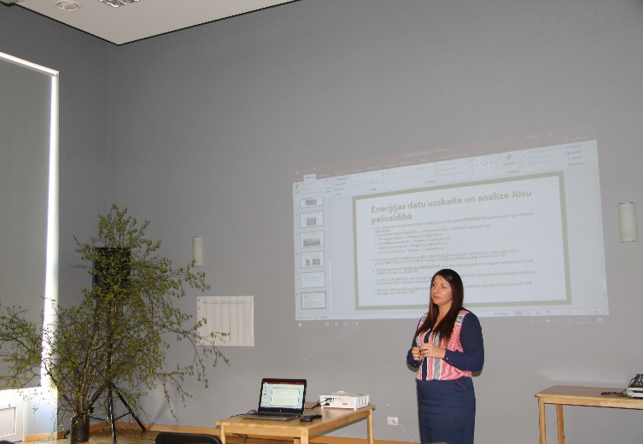

<event 6>

Title: Energy management system development key principles for a municipality building
Date: 11.04.2018.
Place: Kocēni, Latvia

Participants: Municipalities’ representatives

Brief description (main outputs, conclusions, relation to other WPs): Main outputs of the second day of training cycle are analysis of some more energy data, sharing and presenting existing energy management system of one municipality building. The main conclusions are that municipalities’ representatives are passionate about their own municipality and are engaged in the data gathering and analysis process deeply and personally; the tendency of the idea that “everything is fine in my municipality” is shifting to seeing the problems and thinking about systemic solutions. The event is linked to the WP3 data gathering, development of Action plans and road-mapping process.

Photos

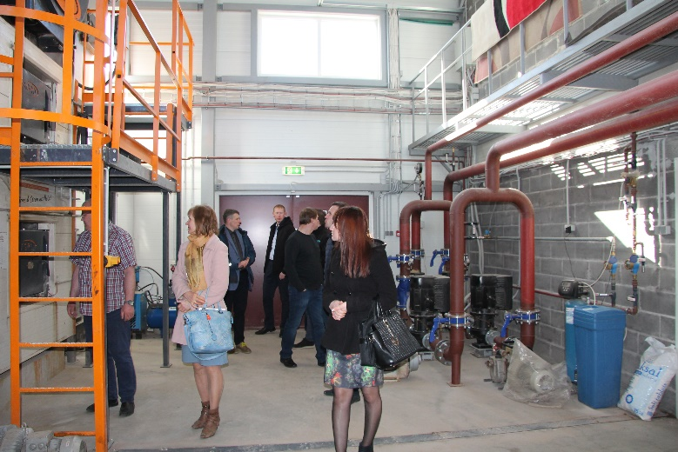 | 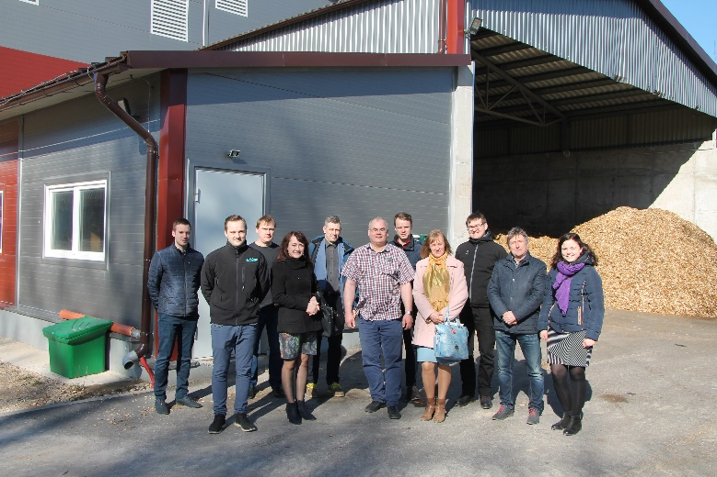
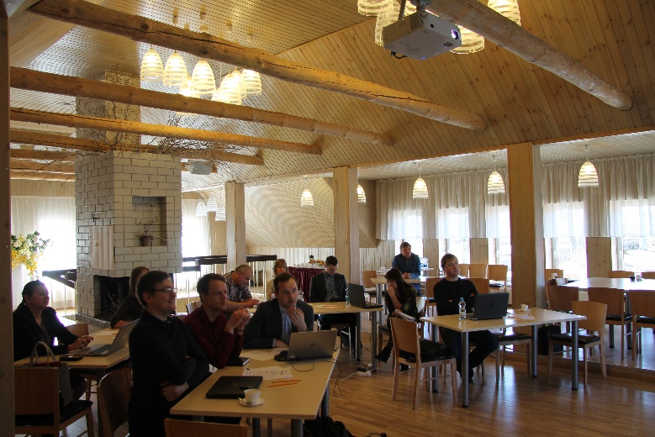 | 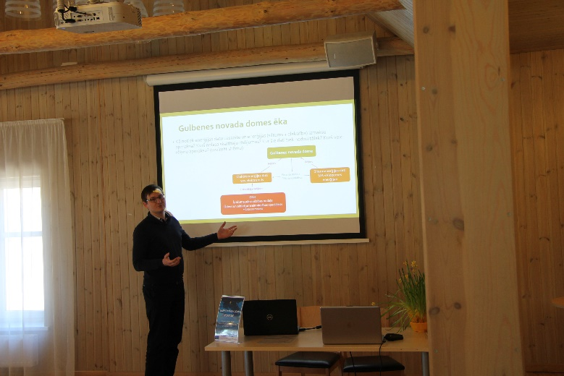

<event 7>

Title: Energy management system development for all municipality buildings
Date: 25.04.2018.
Place: Cēsis, Latvia

Participants: Municipalities’ representatives

Brief description (main outputs, conclusions, relation to other WPs): After the third day of training cycle main outputs are - gained practical knowledge about systemic diverse buildings’ analysis and data gathering approach, knowledge about how to set priorities in choosing the “worst” buildings and the first energy efficiency steps as well as improved presentation skills, networking experience. Besides this workshop about energy vision was raised during this session. The main conclusions – even most of municipalities are not able to make energy management system for more than one municipality building yet due to lack of experience, set system and human resources they are keen to continue sustainable energy development process in municipalities and in the Vidzeme planning region. The event is linked to the WP3 data gathering, development of Action plans and road-mapping process.

Photos

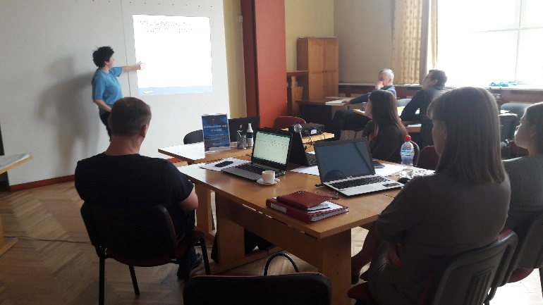 | 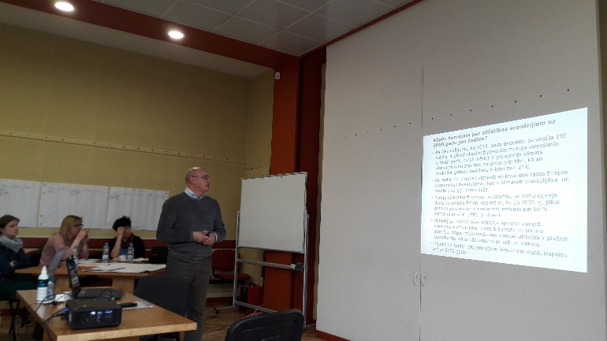
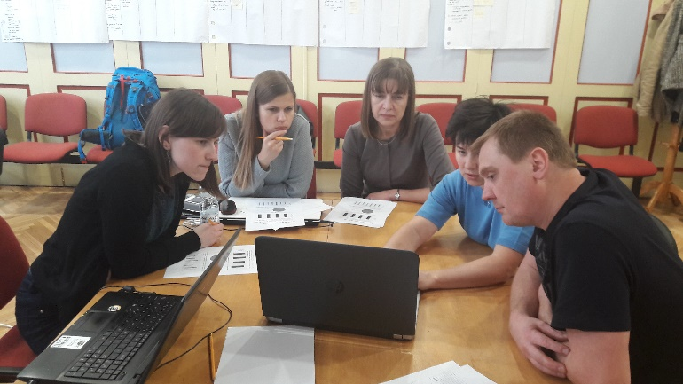 | 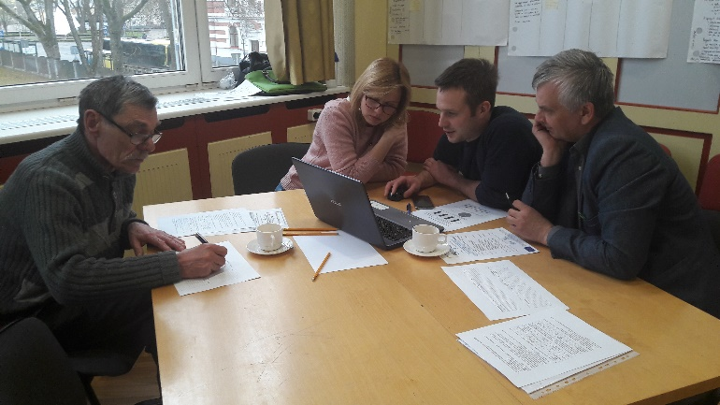

<event 8>

Title: Energy management and municipalities’ Action plans
Date: 9.05.2018.
Place: Valmiera, Latvia

Participants: Municipalities’ representatives

Brief description (main outputs, conclusions, relation to other WPs): The main outputs of the fourth and concluding day of the training dedicated to development of Action plans are knowledge, practical tools and approaches to develop and implement an energy management system in a municipality. The main conclusions - municipalities more and more become the significant part of sustainable energy networking process, highlighting the necessity of the energy plan and energy management system; with the help of practical step by step instructions stakeholders have all knowledge needed to develop Action plans. The event is linked to the WP3 – data gathering, development of Action plan and road-mapping process.

Photos

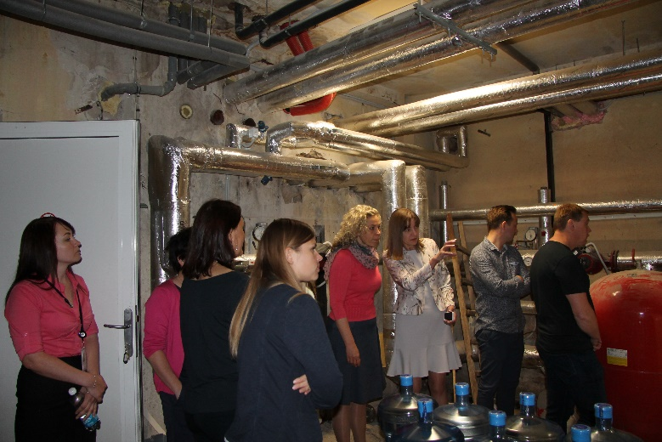 | 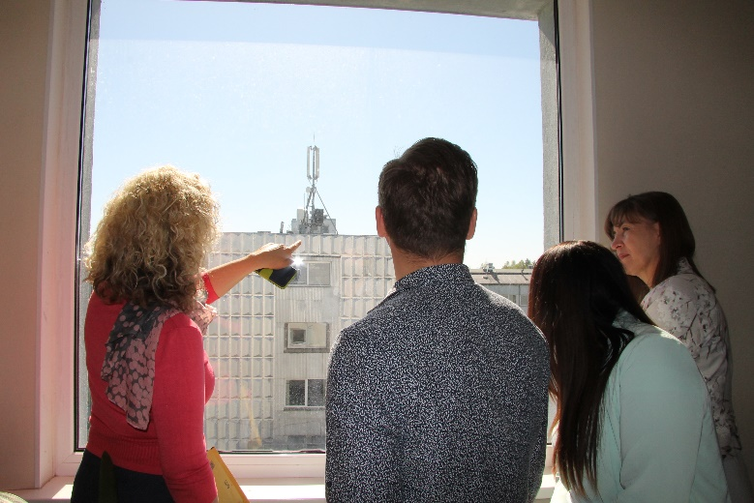
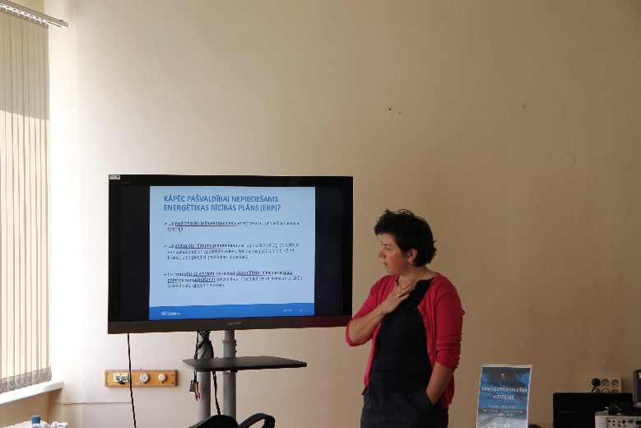 | 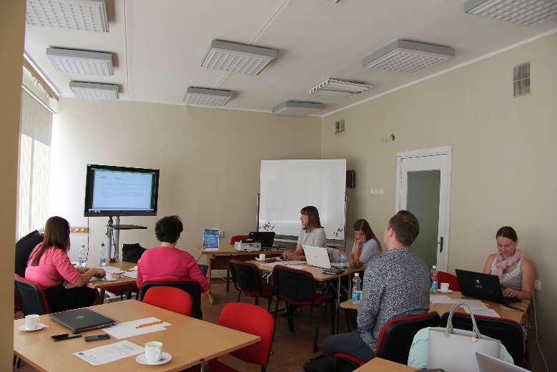

<event 9>

Title: Energy day in Valmiera and study trip to Estonia
Date: 14-15 June 2018.
Place: Valmiera, Latvia
Valga and Tartu, Estonia

Participants: Municipalities’ representatives

Brief description (main outputs, conclusions, relation to other WPs): Main outputs are finished and publicly presented stakeholders’ Action plans, the need of long term vision in energy planning and EU and Vidzeme region, some practical examples of how to communicate about the green thinking, low carbon society and energy consciousness of the municipality to the locals and incomers as well as meaningful experience exchange by visits in various objects in Estonia, meeting with representatives of Tartu Energy Agency. Main conclusion after this event and all the others above is following - stakeholders are cautious towards new initiatives that are tended to change their behaviour and it takes time, effort and valuable deliverables to gain their trust and engagement, but once its done, it gets easier and easier to engage them and get the good results. It is crucial to let the stakeholders come together, communicate and develop local networks. In this way a multiplying effect takes part as well as some problems are enlightened that the stakeholders were unaware of, but other stakeholders had stotted and tackled. It is important to engage the stakeholders through practical and real-life tasks and examples preferably with touchable results, because it helps them to engage them better and they see the point of the change and new approaches and tools. The event is linked to the WP3 –development of Action plan and road-mapping process, WP5 – CEESEN network.

Photos

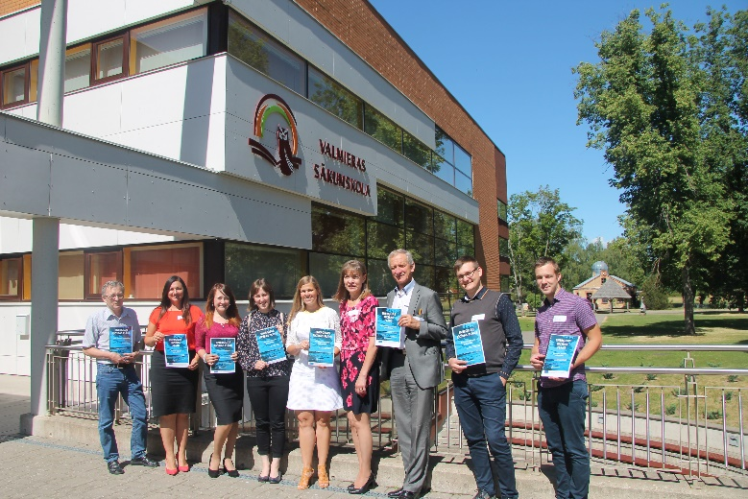 | 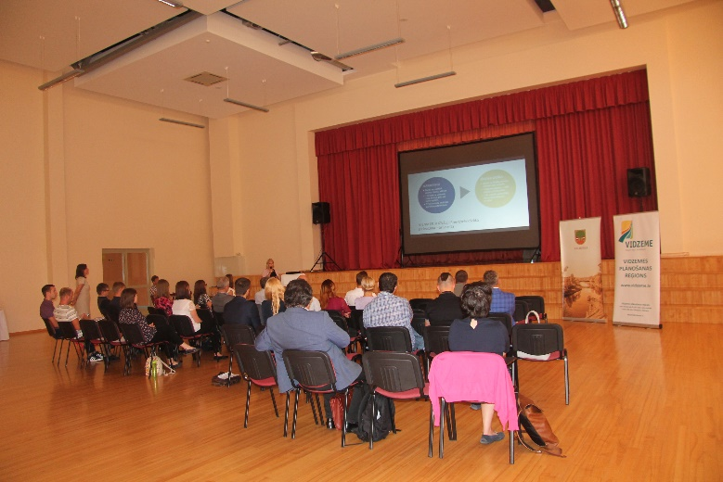
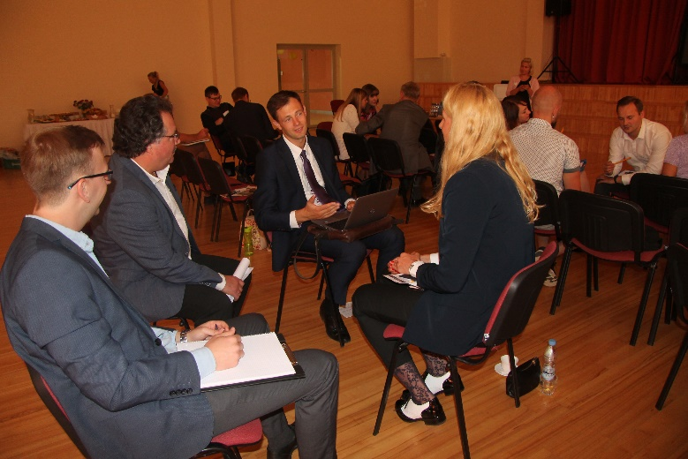 | 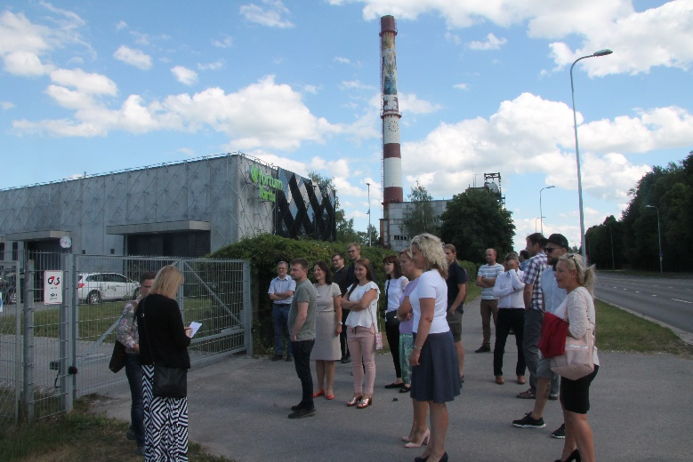
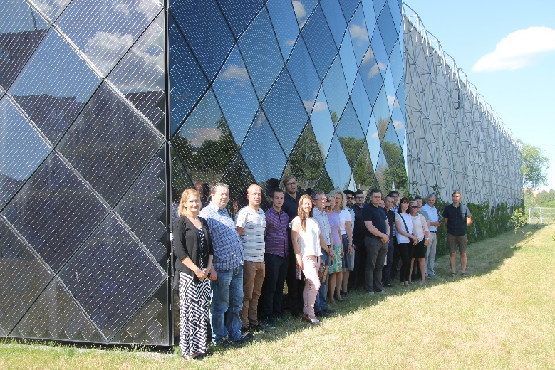 | 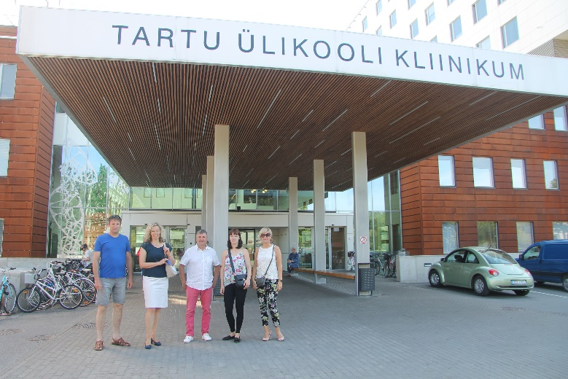
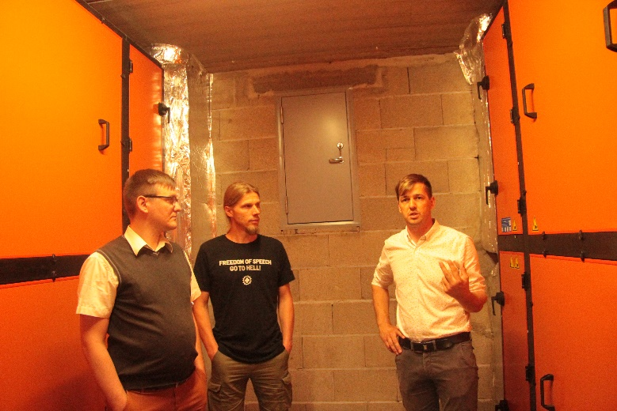 | 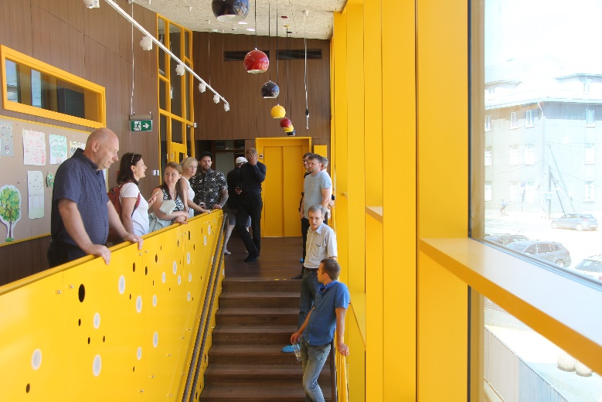

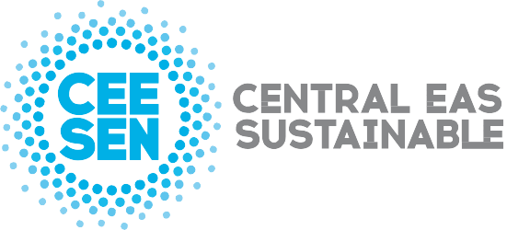

Publisher: CEESEN
All images © CEESEN 2018
All Rights Reserved
Reproduction is authorised, provided the source is acknowledged.

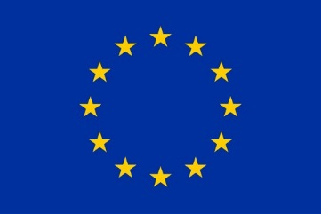
This publication is compiled within the PANEL2050 project “Partnership for New Energy Leadership”. This project has received funding from the European Union’s Horizon 2020 research and innovation programme under the grant agreement No 696173. Disclaimer: The sole responsibility for the content of this material lies with the authors. It does not necessarily represent the views of the European Union and neither EASME nor the European Commission are responsible for any use of this material.

