CEESEN
Trainings report
per country – Czech Republic

- Stakeholder and forerunner trainings / events overview

Title of the event | Date, place | Focus
Regional energy in context | 20.7. 2017, Prague | High-level training for public authorities – Regional energy policies in context
2020 Funding oportunities | 28.11. 2017, České Budějovice | Basic introduction of the possibilities of funding innovative and R&D activities
New thinking and approaches | 14.3. 2018, Prague | Practical training for biogas operators
Mobility in H2020 | 9.4. 2018, České Budějovice | Training for stakeholders on mobility within H2020 opportunities

- Detailed description of the events
Event 1 - Regional energy in context

Title: Regional energy in context
Date: 20.7. 2017
Place: Prague, Ministry of Environment

Participants:

- Vlastimil Šantín, Ministry of Trade and Business (MPO), Department of Energy
- Jaroslav Huďáček, Ministry of Agriculture (MZe), Department of RES
- Richard Nikischev, Ministry of Spatial Development (MMR), Regional policy department
- Lukáš Minařík, Ministry of Environment (MŽP), Energy and Climate protection department
- Jan Weger, The Silva Tarouca Research Institute for Landscape and Ornamental Gardening
- Pavel Chotěboř, Ministry of Environment (MŽP), Nature Preservation department
- Jan Zaplatílek, Ministry of Trade and Business (MPO), Gas and Liquid Fuels department
- Jan Matějka, ECO trend Research Centre s.r.o.
- Leoš Gál, Czech national technology platform for biofuels
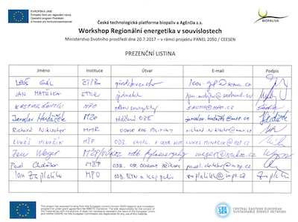

The main goal of this event organized within and based on activities of currently forming stakeholders’ network CEESEN platform was to discuss integrated initiative focused on energy transition and self-sufficiency. It’s a complex, multisectoral intention focused on R&D, innovations, pilot investments as well as infrastructure development.
With regard to intersector character of this initiative all related Ministries were invited (Ministry of Trade and Business, Ministry of Spatial Development, Ministry of Environment and Ministry of Agriculture).
From the energy point of view the focusing point is to foster the regional energy self-sufficiency, job creation and development of regional business. Environmental aspect is dealing with increasing water retention in landscape by improving forestry management and provision of local biomass for local heating systems. From the agricultural point of view application of procedures in order to provide sustainable biomass resources. Spatial development part of the project is based on regional actors synergies through different types of collaborative models.
Main principals of this intention, needs of public authorities, ways of implementations and financing will be matter of discusson.
After introduction of PANEL / CEESEN mission and activities individual topics for each resort were presented and the potential overall integrated approach to all of them was discussed.
1. Identification of regional priorities for biomass and its local use
2. Potential and possibilities of forestry soil fund
3. Potential and possibilites of agricultural soil fund
4. Regional management and business active region
5. Benefits and engagement of local population (regional gasification)

Feedback from each resort:
MMR
- marginal topic, however the contribution to the regional development (rural areas) should be highlighted
- how regional identity could be developed (engagement, use of forest, well-being aspect, social impacts, etc.)
- not compliable with integrational approach according to EC regulations
- impact study needed first
MŽP
- interested in local potential of biomass (local heat plants)
- efficiency of gasification systems vs other technology?
- eco-friendly forestry including biomass utilization
- possible funding from Theta (national research programme), application guarantee could be municipality or association, MPO as well if needed
MPO
- MPO is more focused on national level rather than regional however interested in outputs
- it’s required to fit into other frameworks (NREAP)
- quantification of biomass or potential of gasification
- pattern system, multiplication
- pilot solution is interesting for MPO

Event 2 – 2020 Funding oportunities and excellence and impact of succesful projects

Title: 2020 Funding oportunities and excellence and impact of succesful projects
Date: 28.11. 2017
Place: South Bohemian University in Budweis

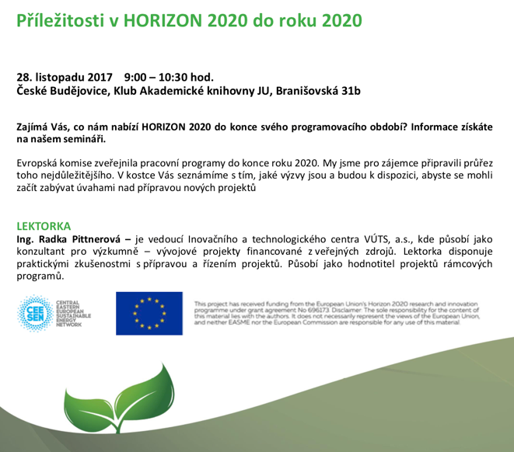
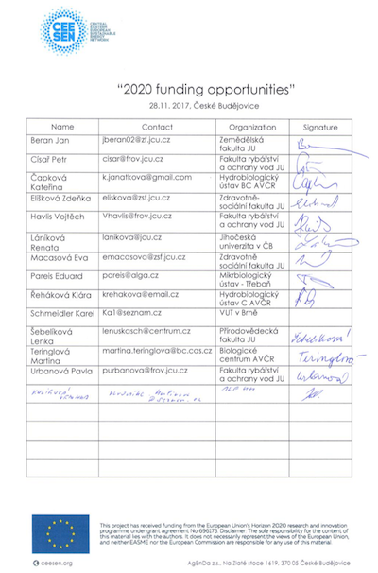

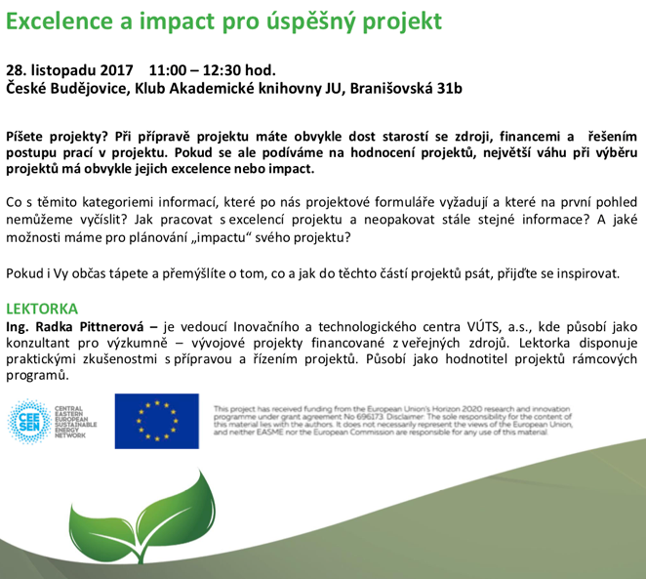

Two training sessions (morning and afternoon) dedicated to introduction of actual funding opportunities within Horizon 2020. Presentation of the most recent calls, priorities, typical examples and best practices in the first morning session and practical guide how to write a succesful proposal.

Event 3 – For today and tomorrow – practical tips and new thinking

Title: For today and tomorrow – practical tips and new thinking
Date: 14.3. 2018
Place: Institute of Chemical Technology, Prague
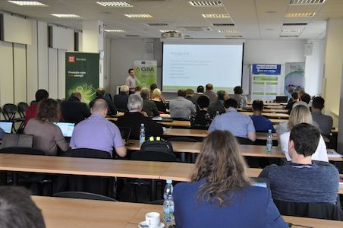
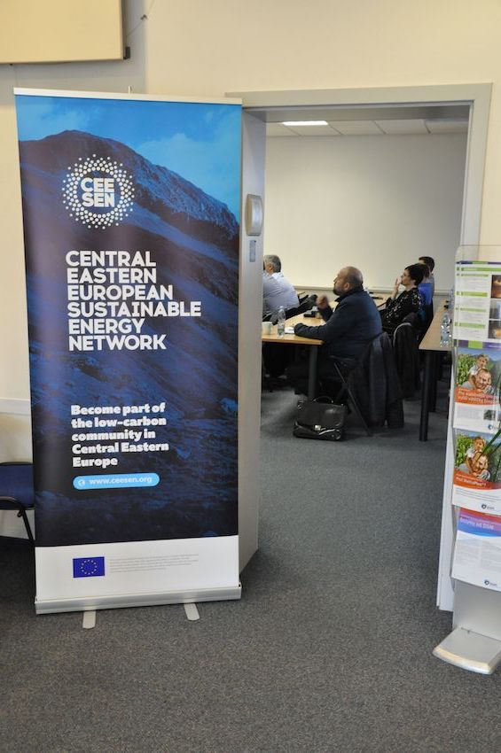

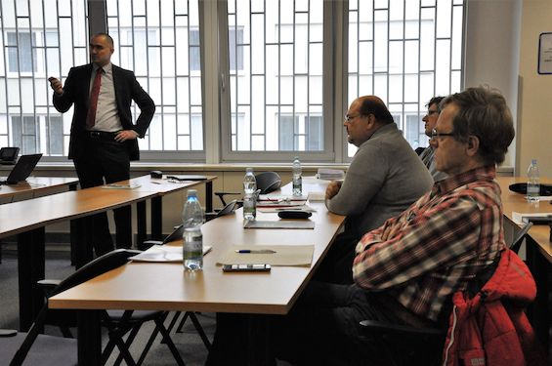

Joint event with one of our stakeholders (Czech Biogas Association) and active participation of the member of CEESEN Advisory Board (Jan Štambaský, president of European Biogas Association) and forerunner Leoš Gál (chairman of National technology platform for biofuels).
Main objective was to present new ways of thinking and approaches with regard to RES (biogas, biomethane) following up energy transition challenges.
Presentations were focused also on e.g. technology foresight elaborated by Czech Biogas Association and based on the survey among biogas plants operator, LCA analysis.
We have managed to invite high-level speakers e.g. from ČEZ (biggest energy producer) and Energy Regulatory Bureau.

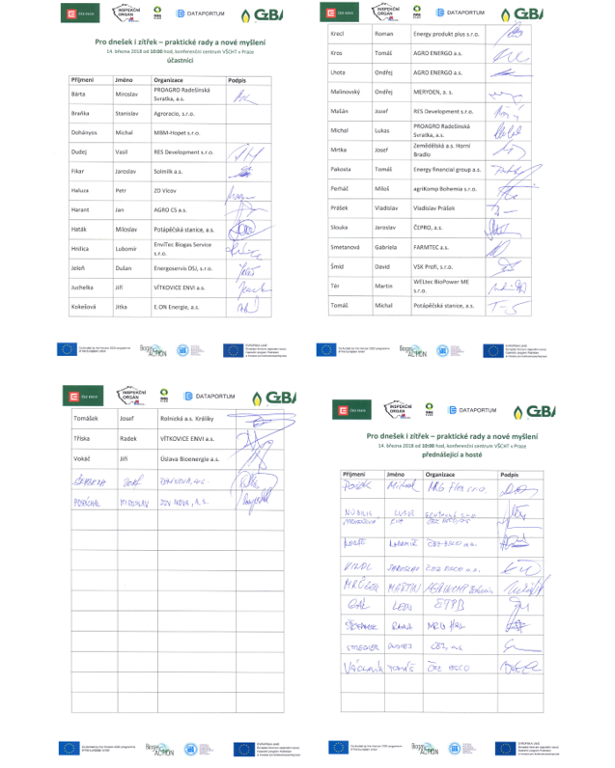
Event 4 – Mobility in Horizon 2020

Title: Mobility in Horizon 2020
Date: 9.4. 2018
Place: University of South Bohemia in Budweis

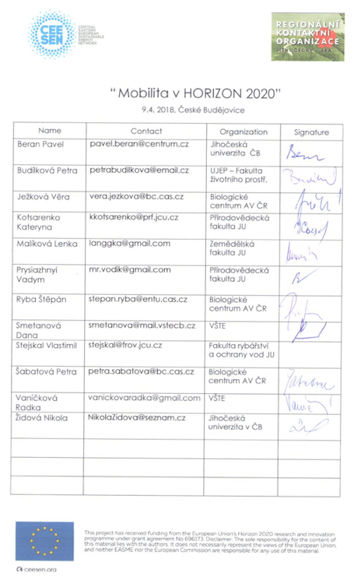
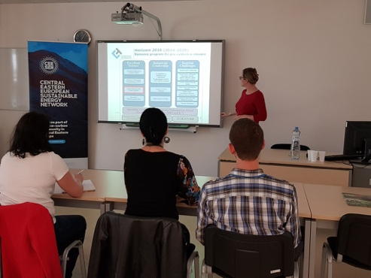
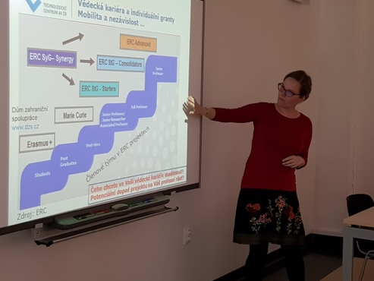

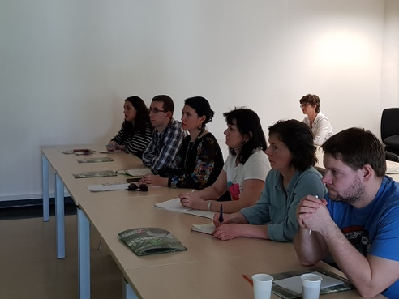
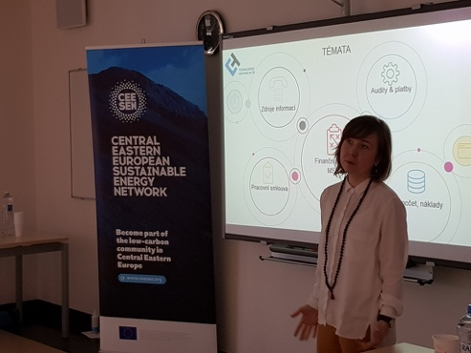

Second training organized in cooperation with Regional Contact Organization was held again at University of South Bohemia this time on the topic of mobility within Horizon 2020 scheme which is key aspect for capacity building among forerunners identified in joint discussion with South Bohemian Agency for Support to Innovative Entrepreneurship which operates local incubator and accelerator.
Main conclusions and outputs from trainings / events:
- introduction of CEESEN activities
- identified forerunners (e.g. Leoš Gál, Jan Matějka)
- capacity building (Mobility and Funding opportunitites within H2020)
- intensive involvement of our stakeholders (e.g. Regional Contact Organization, South Bohemian Agency for Support to Innovative Entrepreneurship, European Biogas Association, South Bohemian University, Czech national technology platform for biofuels, etc.)
- high level decision makers enlightment –
  - Ministry of Trade and Business, Department of Energy,
  - Ministry of Agriculture (MZe),
  - Ministry of Spatial Development (MMR), Regional policy department,
  - Ministry of Environment

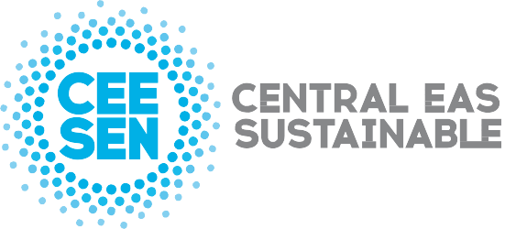

Publisher: CEESEN
All images © CEESEN 2018
All Rights Reserved
Reproduction is authorised, provided the source is acknowledged.

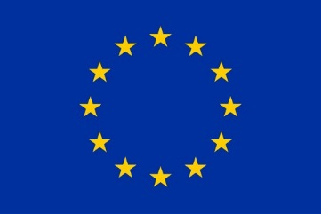
This publication is compiled within the PANEL2050 project “Partnership for New Energy Leadership”. This project has received funding from the European Union’s Horizon 2020 research and innovation programme under the grant agreement No 696173. Disclaimer: The sole responsibility for the content of this material lies with the authors. It does not necessarily represent the views of the European Union and neither EASME nor the European Commission are responsible for any use of this material.

